A Project Report
On
“Cloud Storage Web-application”

Submitted By
Mr. Sahil Sunilkumar Gupta

Under the guidance of
Prof. Harshita Baviskar

DEPARTMENT OF COMPUTER SCIENCE
BHARAT COLLEGE OF ARTS & COMMERCE
Hendrepada, Kulgaon, Badlapur (W)

UNIVERSITY OF MUMBAI

Academic year: 2025 – 2026
INDEX
Sr. No. | INDEX TOPIC | Page
 | Acknowledgement | 3
 | Declaration | 4
 | Preliminary Investigation | 5 - 13
 | Introduction | 6
 | Goals and Objectives | 7
 | Problem Statement | 7
 | Proposed System | 8
 | Current working of proposed system | 9
 | Advantages of proposed system | 10
 | Software Requirements | 11
 | Feasibility study | 12
 | System Analysis | 14 - 20
 | Use-Case Diagram | 15
 | Sequence Diagram | 16
 | Activity Diagram (User & admin) | 17
 | Data Flow Diagram | 19
 | State Diagram | 20
 | System Design | 21 – 24
 | System architecture diagram | 22
 | Deployment diagram | 23
 | Component diagram | 24
 | System Coding | 25 - 103
 | Tables with attribute and constraint | 26
 | Program description | 27
 | Coding | 29 - 103
 | Screen layout | 103
 | Limitations | 106
 | Scope for future work | 107
 | Conclusion | 108
 | Reference | 108

ACKNOWLEDGEMENT

Around a period of three months, I was working hard to achieve my goal. I have strived hard to complete my project. My goal was to give an exceptional and appreciating performance. Though there were lots of problems I had faced, I moved on and on. Firstly, I would like to thank my Principal Dr. Deepak Sable who helped me learn a lot through this project. His ideas and comments aided in the completion of this project. I am grateful to the college administration for providing me with such a significant chance.
I would like to thank Prof. Shweta Mohite (Co-Ordinator of CS & IT Department) for providing me the opportunity to do such a project. I am very much thankful to my Project Guide, Prof. Harshita Baviskar (CS & IT Department), for her uninterrupted support in the development of the project and for enabling me to complete my project within the given period of time. She was always there to listen and give advice and also taught me how to express my ideas and views professionally. I would also like to thank all my friends, family, and everybody else who helped me in any way during this project. Last but not the least, I want to acknowledge all my friends and colleagues who supported me in my project.

DECLARATION

I, Sahil Gupta, hereby declare that the project entitled
“Cloud Storage web-application” submitted in the partial fulfilment for the award of Bachelor of Science in Computer Science during the academic year 2025 – 202 is my original work and the project has not formed the basis for the award of any degree, associateship, fellowship or any other similar titles.

Signature of the Student:

Place:

Date:

PRELIMINARY
INVESTIGATION

INTRODUCTION
- The Cloud Storage Web-application is developed to provide a secure, efficient, and user-friendly platform for storing, managing, and accessing digital files over a local network environment.
- The system works on independent machines where one computer acts as a Server PC, and other computers (clients) connect to it through the same Wi-Fi network. The server manages data storage and processing, while client machines access the system through a web interface.
- It provides a centralized storage system where users can upload, download, organize, and manage their files from any connected device within the network.
- The web-application includes essential modules such as user authentication, file upload and download management, storage monitoring, and plan-based access control.
- The system offers different storage plans (Free and Pro), where each user is assigned a specific storage limit. Automatic storage tracking ensures that users cannot exceed their allocated storage space.
- Real-time updates are implemented to reflect changes in storage usage, file uploads, file deletions, and administrative actions instantly across all connected clients within the network.
- Administrative functionalities are included to manage users, upgrade or downgrade plans, monitor storage usage, and maintain overall system control. Any changes made by the administrator are immediately reflected in the user dashboards connected to the server.
- The web-application ensures data security through user authentication, controlled access permissions, secure file handling, and structured backend management.
- The system enhances productivity by providing fast file handling, reliable storage tracking, and seamless communication between client and server machines over a network-based architecture.
- Therefore, the proposed Cloud Storage Web-application automates digital file storage and management processes within a networked environment, improving efficiency, accessibility, and data organization for both users and administrators.

GOALS & OBJECTIVES
The project introduces a centralized cloud-based web web-application with the objective of making digital file management more secure, efficient, and user-friendly within a network environment.
This project demonstrates how modern web technologies and client–server architecture can simplify data storage, sharing, monitoring, and administrative control processes. The main objectives of this web-based system are:
- To develop a secure web platform where users can upload, download, organize, and manage their files through a browser interface.
- To implement user authentication and role-based access control, distinguishing between User and Admin roles.
- To allocate storage limits based on subscription plans (Free and Pro) and automatically monitor each user's storage usage.
- To prevent users from exceeding their assigned storage capacity through real-time storage tracking and validation mechanisms.
- To enable administrators to upgrade or downgrade user subscription plans and manage user accounts efficiently through an admin dashboard.
- To provide real-time updates for file uploads, deletions, storage usage changes, and plan modifications using modern web technologies.
- To establish a reliable client–server communication system where one system acts as the server and multiple client machines can access the web web-application over the same network.
- To enhance data accessibility, organization, and overall system efficiency through a structured and automated web-based cloud storage solution.

PROBLEM STATEMENT
- In many organizations and local network environments, users face difficulties in managing and storing digital files securely due to the absence of a centralized web-based storage system. Files are often scattered across multiple devices such as laptops, pen drives, and external hard disks, increasing the risk of data loss and mismanagement.
- There is a need for an efficient web-based system that allows users to upload, store, retrieve, and monitor files in an organized and structured manner through a browser interface within a network.
- Managing storage limits manually is challenging, especially when different users require different subscription plans (such as Free and Pro) with predefined storage quotas.
- Monitoring storage usage, tracking file uploads and downloads, and maintaining accurate records of user activities becomes complex without an automated client–server system.
- Administrators require a centralized management dashboard to monitor user accounts, control storage allocation, upgrade or downgrade subscription plans, and maintain overall system control efficiently.
- Without a structured cloud storage web web-application operating on a server–client model, users may experience data inconsistency, limited accessibility within the network, lack of real-time updates, and increased risk of data loss, while administrators struggle to manage storage resources and user accounts effectively.

PROPOSED SYSTEM
- The proposed system is a centralized Cloud Storage Web Web-application that provides a secure and reliable platform for storing, managing, and accessing digital files over a local network using a client–server architecture.
- The system operates with one machine functioning as the Server, which manages the database and file storage, while multiple client machines access the web-application through a web browser within the same network.
- It stores and retrieves user files efficiently while maintaining accurate records of storage usage, file information, and user activities in real-time.
- The web-application implements structured user authentication and role-based access control (User and Admin) to ensure data security, controlled access, and proper system management.
- It provides subscription-based storage plans (Free and Pro), where each plan has a predefined storage limit. Automatic storage monitoring prevents users from exceeding their allocated storage capacity.
- Users can upload, download, organize, delete, and manage their files through a simple, responsive, and interactive web dashboard.
- An Admin Panel is included to manage user accounts, monitor storage usage, upgrade or downgrade subscription plans, and maintain overall system control.
- The system ensures real-time updates for file uploads, storage changes, and administrative actions across all connected clients using modern web technologies.
- The proposed solution enhances accessibility within the network, improves data organization, ensures storage control, and provides efficient communication between server and client systems.

CURRENT WORKING OF PROPOSED SYSTEM
- The proposed system is completely web-based and follows a client–server architecture, where one computer acts as the Server and other machines access the system through a web browser over the same Wi-Fi network. This eliminates manual file handling and reduces dependency on physical storage devices.
- Users can register and log in securely through the web interface. After authentication, they are redirected to a personalized dashboard where they can upload, download, organize, and delete files.
- When a user uploads a file, the request is sent to the server, where the file is stored and the storage usage is updated in the database.
- The system automatically tracks storage usage for each user and restricts further uploads if the user exceeds their allocated storage limit based on their subscription plan (Free or Pro).
- Real-time updates ensure that file uploads, deletions, storage changes, and plan updates are instantly reflected on the user dashboard without requiring manual refresh.
- Administrators can log in to the Admin Panel to monitor all registered users, view storage usage, upgrade or downgrade subscription plans, and manage overall system resources.
- Security is maintained through structured authentication mechanisms and role-based access control, ensuring that users can access only their own files while administrators have controlled system-level access.
- The server maintains structured records of user accounts, file details, storage usage, and subscription plans in a centralized database.
- The system provides instant updates and accurate storage tracking, overcoming the limitations of traditional local storage methods and improving efficiency within a network-based environment.

ADVANTAGES OF PROPOSED SYSTEM
- Centralized Storage Platform:
The system provides a centralized web-based storage environment where all files are stored on a server and accessed by multiple client machines over the network, ensuring better organization and control.
- Accessible Within Network:
Users connected to the same Wi-Fi network can securely access their files from different devices through a web browser without relying on physical storage devices.
- User-Friendly Interface:
The dashboard is designed to be simple, interactive, and easy to use for both users and administrators, enabling smooth navigation and efficient file management.
- Time-Saving & Efficient:
File uploads, downloads, deletions, and storage monitoring are processed quickly, with real-time updates reflecting changes instantly across connected clients.
- Automatic Storage Management:
The system automatically monitors storage usage and prevents users from exceeding their allocated storage limits based on their subscription plans (Free or Pro).
- Secure & Reliable:
Data security is ensured through user authentication, role-based access control, and structured backend management, protecting files from unauthorized access.
- Scalable & Upgradeable:
The web-based architecture allows future enhancements such as file sharing, advanced encryption, remote access over the internet, and additional subscription plans.
- Administrative Efficiency:
The Admin Panel simplifies user management, enables plan upgrades or downgrades, monitors storage usage, and reduces manual errors by maintaining structured and automated records.

SOFTWARE REQUIREMENTS
Back End:
• Node.js
• Express.js
• MongoDB (Database)
• Mongoose (MongoDB ODM)
• Socket.io (Real-time Communication)

Front End:
• React.js
• HTML5
• CSS3
• JavaScript (ES6+)
• Axios (API Communication)

Development Tools:
• Visual Studio Code (VS Code)
• npm (Node Package Manager)
• Postman (API Testing)
• Web Browser (Google Chrome / Microsoft Edge)

Operating System:
• Windows 10 or Above (Server and Client Systems within the same network)

Feasibility Study
In the preliminary investigation, the feasibility of the Cloud Storage Web Web-application is analysed under four major aspects:

1. Organisational Feasibility
The project is designed to provide a centralized and secure web-based platform for storing and managing digital files over a local network. It simplifies file management by reducing dependency on traditional physical storage devices such as pen drives and external hard disks.
The system allows multiple users within the same network to access a centralized server through a web browser. Users can upload, download, and monitor their storage usage efficiently, while administrators can manage user accounts and subscription plans through an admin dashboard.
This improves overall data organization, reduces manual management efforts, enhances collaboration within the network, and increases productivity within an organization or institution.

2. Technical Feasibility
The project is technically feasible as it is developed using modern, reliable, and widely adopted web technologies such as Node.js, Express.js, MongoDB, React.js, HTML, CSS, and JavaScript.
The system follows a client–server architecture where one system acts as the server and multiple client systems access the web-application through a web browser over the same Wi-Fi network. These technologies are open-source, platform-independent, and compatible with major operating systems and browsers.
Real-time communication and automatic storage tracking are implemented efficiently, ensuring smooth system performance with minimal technical risk. The hardware and software requirements are basic and easily available.

3. Operational Feasibility
The system is operationally feasible because it provides a simple, interactive, and user-friendly web interface for both users and administrators.
Users can easily register, log in, upload, download, delete, and organize their files while monitoring their storage usage based on their subscription plan (Free or Pro).
Administrators have access to a dedicated Admin Panel where they can manage user accounts, upgrade or downgrade plans, and monitor storage allocation and usage across the network.
The intuitive dashboard design and structured information flow ensure that users and administrators can operate the system effectively with minimal training.

4. Economic Feasibility
The project is economically feasible as it uses free and open-source technologies, eliminating licensing and software costs.
The primary requirements include basic computer systems, a local Wi-Fi network, and minimal maintenance. Since the system centralizes file storage on a server machine within the network, it reduces the need for multiple physical storage devices.
By automating file management, tracking storage usage, and providing centralized control, the system reduces operational inefficiencies and manual errors, making it a cost-effective and sustainable solution.

SYSTEM
ANALYSIS

Use-Case Diagram:
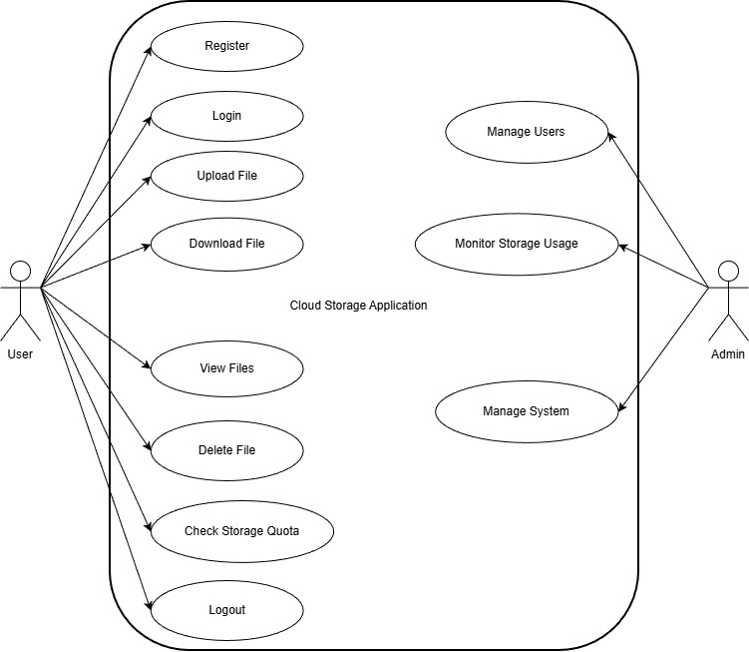

Sequence Diagram: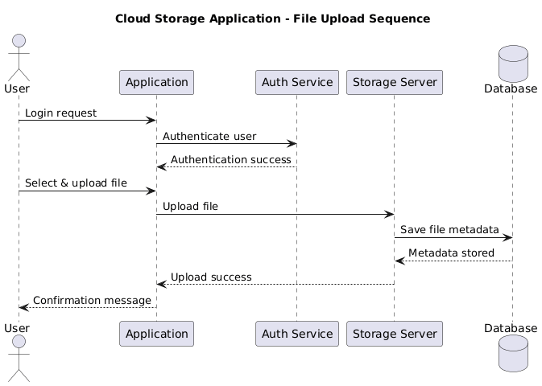

Activity Diagram (User):
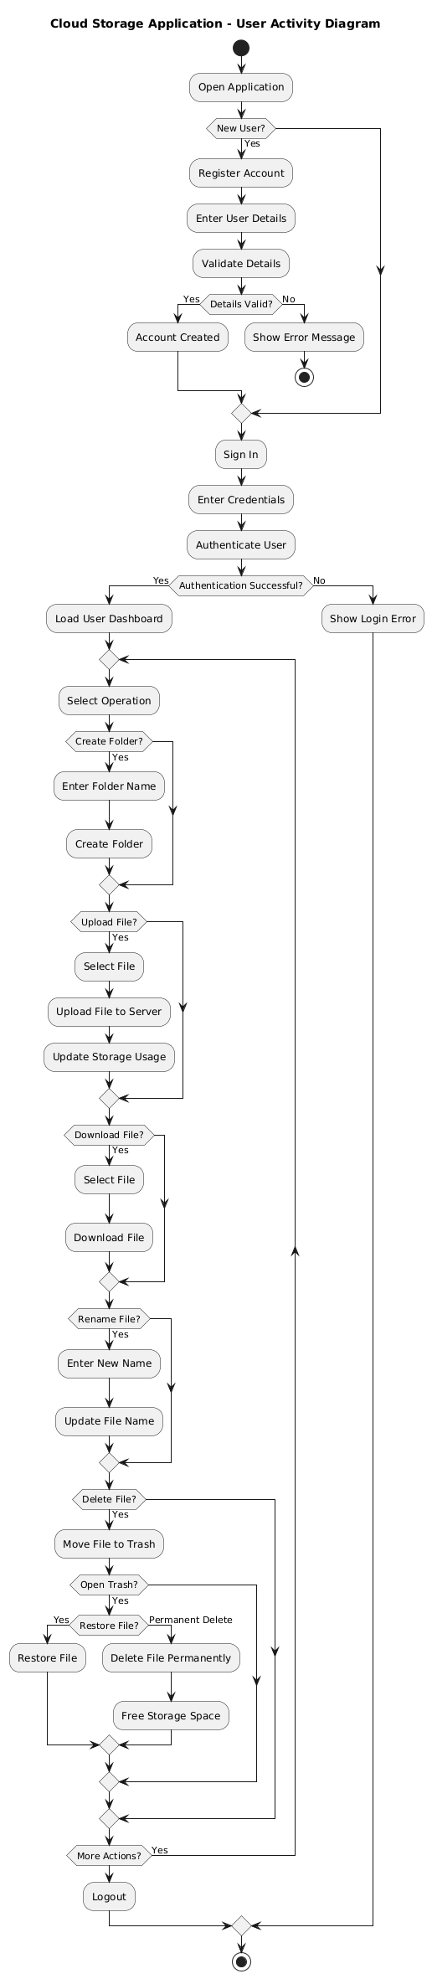
Activity Diagram (Admin):
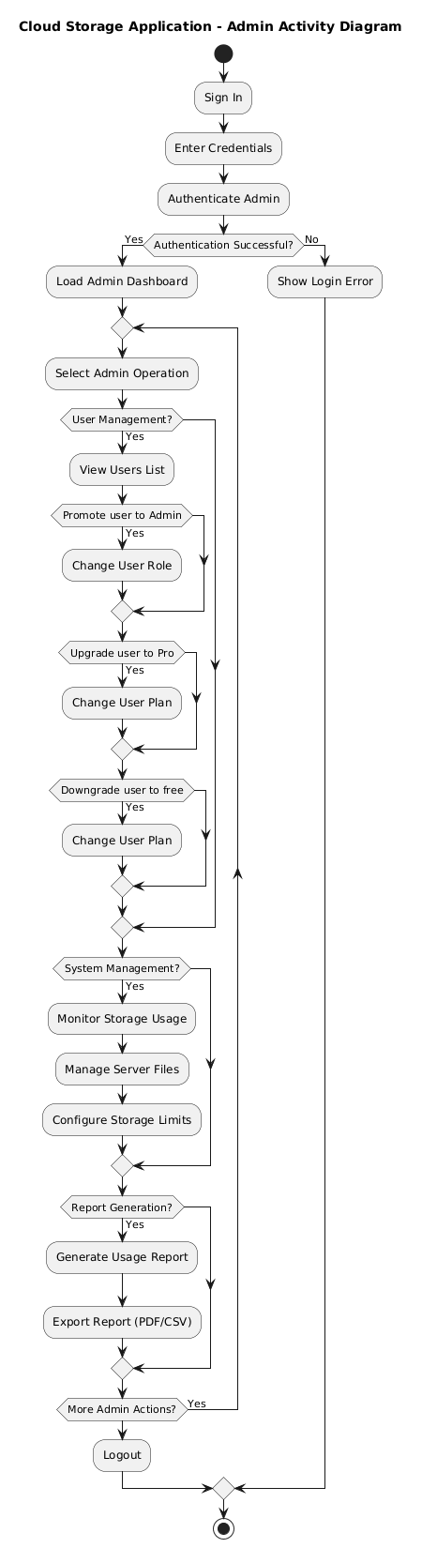
Data Flow Diagram:
DFD0: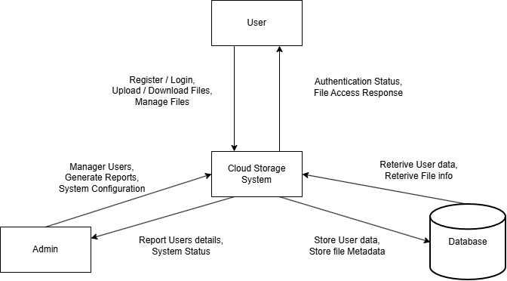
DFD1: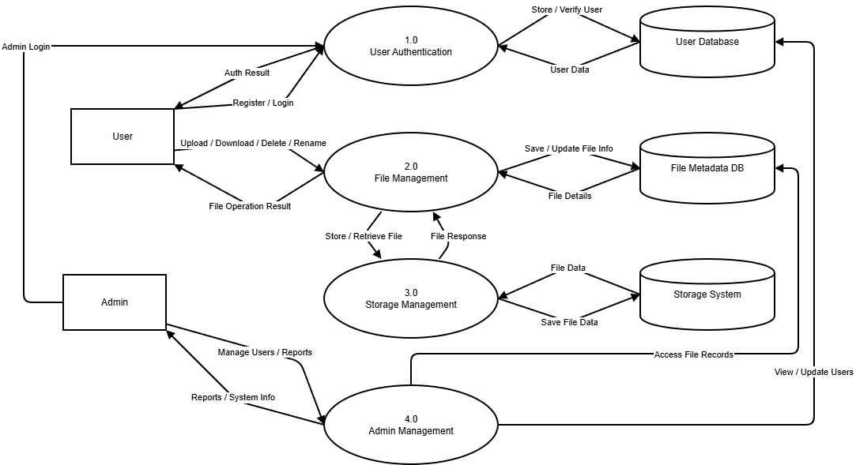

State Diagram: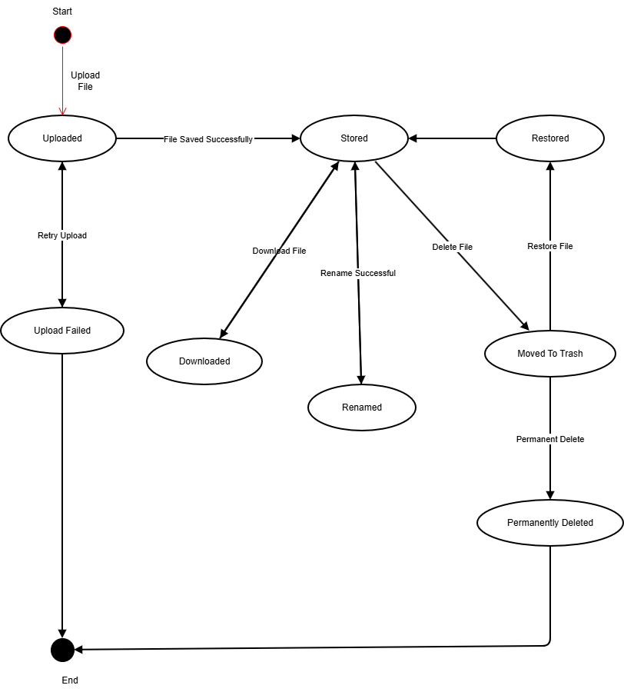

SYSTEM
DESIGN

System Architecture:
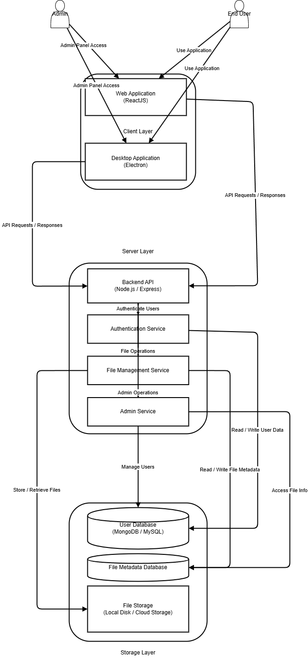
Deployment Diagram:
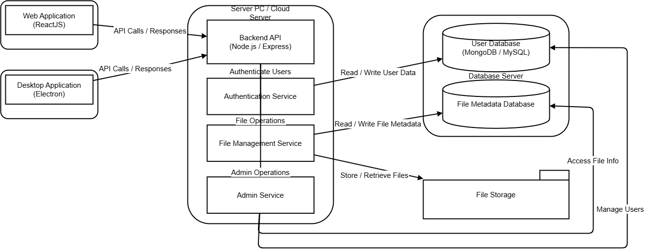

Component Diagram: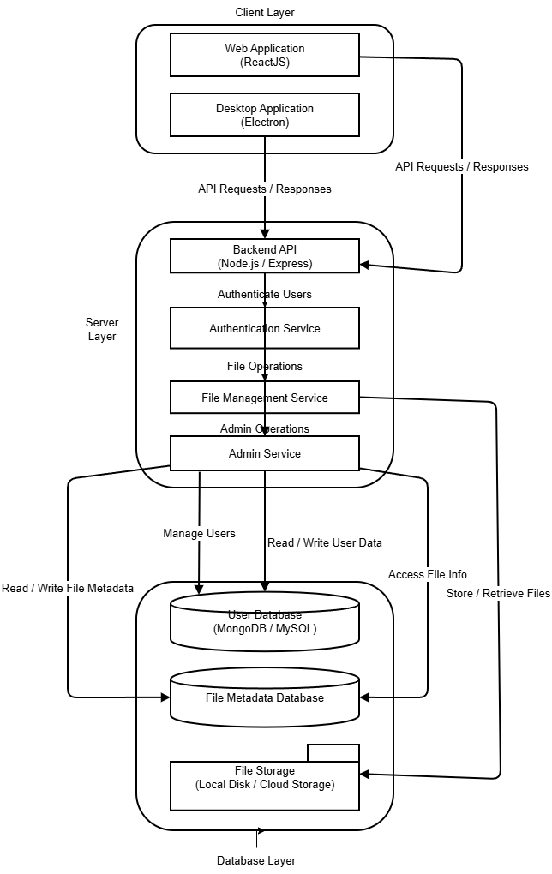

SYSTEM
CODING

Tables with Attributes and Constraints:
DATABASE NAME: cloud_storage
Table Name: Users
KEY | FIELD NAME | DATATYPE | ALLOW NULL
Primary | _id | ObjectId | NO
 | Role | varchar(50) | NO
 | fullName | varchar(200) | NO
 | Age | int(3) | NO
 | Email | varchar(200) | NO
 | password | varchar(200) | NO
 | storageUsed | int(20) | NO
 | Plan | varchar(50) | NO
 | fileCount | int(20) | NO
 | createdAt | datetime | NO
 | updatedAt | datetime | NO

Table Name: Folders
KEY | FIELD NAME | DATATYPE | ALLOW NULL
Primary | _id | ObjectId | NO
 | userId | ObjectId | NO
 | name | varchar(200) | NO
 | createdAt | datetime | NO
 | updatedAt | datetime | NO
Table Name: Files
KEY | FIELD NAME | DATATYPE | ALLOW NULL
Primary | _id | ObjectId | NO
 | name | varchar(300) | NO
 | path | varchar(500) | NO
 | size | int(20) | NO
 | category | varchar(50) | NO
 | folderId | ObjectId | NO
 | userId | ObjectId | NO
 | isTrashed | boolean | NO
 | createdAt | datetime | NO
 | updatedAt | datetime | NO

Program Description (Classes)

Class Number: 1
Class Name: Login & Register (server.js / users collection)
Purpose: To handle user login and registration
Input Table: Users
Output Table: Users
Validation: Accessible to Users only

Class Number: 2
Class Name: Upload File (upload.html / file collection)
Purpose: To upload files to a selected folder
Input Table: File
Output Table: File
Validation: Accessible to Users only

Class Number: 3
Class Name: Create Folder (folder.html / folder collection)
Purpose: To create a new folder for file organization
Input Table: Folder
Output Table: Folder
Validation: Accessible to Users only

Class Number: 4
Class Name: View Files (dashboard.html / file & folder collections)
Purpose: To view all files and folders
Input Table: File, Folder
Output Table: File, Folder
Validation: Accessible to Users only

Class Number: 5
Class Name: Delete/Trash File (trash.html / file collection)
Purpose: To move files to trash or restore them
Input Table: File
Output Table: File
Validation: Accessible to Users only

Class Number: 6
Class Name: File Management (file-management.html / file collection)
Purpose: To rename, move, or categorize files
Input Table: File, Folder
Output Table: File
Validation: Accessible to Users only

Class Number: 7
Class Name: User Management (admin.html / users collection)
Purpose: Admin can manage users, storage, and plans
Input Table: Users
Output Table: Users
Validation: Accessible to Admin only

Coding:
Dashboard.jsx:
import API_BASE from "../config";
import React, { useState, useRef, useEffect } from "react";
import { Plus, Folder, Upload } from "lucide-react";
import "./Dashboard.css";
import Logo from "../assets/airbox-logo.png";
import { io } from "socket.io-client";
const socket = io(API_BASE, {
autoConnect: false,
});
export default function Dashboard() {
const fileInputRef = useRef(null);
const [userPlan, setUserPlan] = useState(null);
const [userStorageLimit, setUserStorageLimit] = useState(null);
/* ---------------- STATE ---------------- */
const [view, setView] = useState("home");
const [files, setFiles] = useState([]);
const [folders, setFolders] = useState([]);
const [showModal, setShowModal] = useState(false);
const [folderName, setFolderName] = useState("");
const [contextMenu, setContextMenu] = useState(null);
const [editingFolderId, setEditingFolderId] = useState(null);
const [tempName, setTempName] = useState("");
const [activeFolder, setActiveFolder] = useState(null);
const [draggedFile, setDraggedFile] = useState(null);
const [fileMenu, setFileMenu] = useState(null);
const [activeFileId, setActiveFileId] = useState(null);
const [searchQuery, setSearchQuery] = useState("");
const [editingFileId, setEditingFileId] = useState(null);
const [tempFileName, setTempFileName] = useState("");
const [mobileMenuOpen, setMobileMenuOpen] = useState(false);
// Convert bytes to GB (2 decimal places)
const bytesToGB = (bytes) => {
return (bytes / (1024 * 1024 * 1024)).toFixed(2);
};
const normalizeFile = (file) => ({
...file,
id: file._id,
url: `${API_BASE}/${file.path}`,
});
/* ---------------- STORAGE ---------------- */
const usedBytes = files.reduce(
(sum, f) => sum + (Number(f.size) || 0),
0
);
const usagePercent = userStorageLimit
? Math.min((usedBytes / userStorageLimit) * 100, 100)
: 0;
const isStorageFull = userStorageLimit
? usedBytes >= userStorageLimit
: false;
const freeBytes =
userStorageLimit != null
? Math.max(userStorageLimit - usedBytes, 0)
: 0;
const isAlmostFull = usagePercent >= 90 && !isStorageFull;
/*----- db to dashboard data------*/
const refreshFiles = async () => {
try {
const token = localStorage.getItem("token");
if (!token) return;
const folderRes = await fetch(`${API_BASE}/api/folders`, {
headers: { Authorization: `Bearer ${token}` },
});
const fileRes = await fetch(`${API_BASE}/api/files`, {
headers: { Authorization: `Bearer ${token}` },
});
const foldersData = await folderRes.json();
const filesData = await fileRes.json();
setFolders(foldersData);
setFiles(filesData.map(normalizeFile));
} catch (err) {
console.error("Refresh error:", err);
}
};
const fetchUserInfo = async () => {
try {
const token = localStorage.getItem("token");
if (!token) return;
const res = await fetch(`${API_BASE}/api/user/me`, {
headers: { Authorization: `Bearer ${token}` },
});
const data = await res.json();
if (!res.ok) {
console.error("User fetch failed:", data.message);
return;
}
console.log("User info loaded:", data);
setUserPlan(data.plan);
setUserStorageLimit(data.storageLimit);
} catch (err) {
console.error("Fetch user error:", err);
}
};
useEffect(() => {
refreshFiles();
fetchUserInfo();
}, []);
useEffect(() => {
const token = localStorage.getItem("token");
if (!token) return;
socket.disconnect();
socket.off();
const payload = JSON.parse(atob(token.split(".")[1]));
socket.auth = { token };
socket.connect();
socket.on("connect", () => {
socket.emit("join-user", payload.id);
});
socket.on("user-plan-updated", (data) => {
setUserPlan(prev => {
if (prev === data.plan) return prev;
return data.plan;
});
setUserStorageLimit(prev => {
if (prev === data.storageLimit) return prev;
return data.storageLimit;
});
});
socket.on("user-files-updated", refreshFiles);
socket.on("user-storage-updated", refreshFiles);
return () => {
socket.off();
socket.disconnect();
};
}, []);
/* ---------------- FILE LOGIC ---------------- */
const detectCategory = (file) => {
if (file.type.startsWith("image")) return "image";
if (file.type.startsWith("video")) return "video";
if (
file.type.includes("pdf") ||
file.type.includes("word") ||
file.type.includes("excel") ||
file.type.includes("presentation") ||
file.type.includes("text")
)
return "doc";
return "other";
};
const handleUpload = async (e) => {
const selectedFiles = Array.from(e.target.files);
const token = localStorage.getItem("token");
const selectedBytes = selectedFiles.reduce(
(sum, f) => sum + f.size,
0
);
// 🔒 FRONTEND QUOTA CHECK
if (!userStorageLimit) {
alert("Storage info not loaded yet");
return;
}
if (usedBytes + selectedBytes > userStorageLimit) {
alert(
`Upload blocked: storage limit exceeded (${bytesToGB(userStorageLimit)} GB)`
);
fileInputRef.current.value = "";
return;
}
for (const file of selectedFiles) {
try {
const formData = new FormData();
formData.append("file", file);
formData.append("category", detectCategory(file));
formData.append("folderId", activeFolder?._id || "");
const res = await fetch(`${API_BASE}/api/files/upload`, {
method: "POST",
headers: {
Authorization: `Bearer ${token}`,
},
body: formData,
});
if (!res.ok) {
const err = await res.json();
alert(err.message || "Upload failed");
break;
}
const saved = await res.json();
setFiles(prev => [...prev, normalizeFile(saved)]);
} catch (err) {
console.error("Upload error:", err);
}
}
fileInputRef.current.value = "";
};
const handleRestore = async (file) => {
const token = localStorage.getItem("token");
const res = await fetch(
`${API_BASE}/api/files/${file._id}/restore`,
{
method: "PUT",
headers: {
Authorization: `Bearer ${token}`,
},
}
);
if (!res.ok) {
const err = await res.json();
console.error(err.message);
return;
}
const restoredFile = await res.json();
setFiles(prev =>
prev.map(f =>
f._id === restoredFile._id
? normalizeFile(restoredFile)
: f
)
);
setActiveFileId(null);
};
const startFileRename = (file) => {
setEditingFileId(file.id);
setTempFileName(file.name);
setActiveFileId(null);
};
const confirmFileRename = async (file) => {
if (!tempFileName.trim()) {
setEditingFileId(null);
return;
}
const token = localStorage.getItem("token");
try {
const res = await fetch(
`${API_BASE}/api/files/${file.id}/rename`,
{
method: "PUT",
headers: {
"Content-Type": "web-application/json",
Authorization: `Bearer ${token}`,
},
body: JSON.stringify({ name: tempFileName }),
}
);
if (!res.ok) {
const err = await res.json();
throw new Error(err.message || "Rename failed");
}
const updatedFile = await res.json();
setFiles(prev =>
prev.map(f =>
f.id === updatedFile._id ? { ...f, name: updatedFile.name } : f
)
);
setEditingFileId(null);
setTempFileName("");
} catch (err) {
alert(err.message);
setEditingFileId(null);
}
};
/* ---------------- FOLDER ACTIONS ---------------- */
const createFolder = async () => {
if (!folderName.trim()) return;
const token = localStorage.getItem("token");
const res = await fetch(`${API_BASE}/api/folders`, {
method: "POST",
headers: {
"Content-Type": "web-application/json",
Authorization: `Bearer ${token}`, // 🔥 FIX
},
body: JSON.stringify({
name: folderName,
}),
});
const data = await res.json();
if (!res.ok) {
alert(data.message || "Failed to create folder");
return;
}
setFolders((prev) => [...prev, data]); // only add if success
setFolderName("");
setShowModal(false);
};
const startRename = (folderId) => {
const folder = folders.find(f => f._id === folderId);
if (!folder) return;
setEditingFolderId(folder._id);
setTempName(folder.name);
setContextMenu(null);
};
const confirmRename = async (folderId) => {
if (!tempName.trim()) return;
const token = localStorage.getItem("token");
try {
const res = await fetch(
`${API_BASE}/api/folders/${folderId}`,
{
method: "PUT",
headers: {
"Content-Type": "web-application/json",
Authorization: `Bearer ${token}`,
},
body: JSON.stringify({ name: tempName }),
}
);
if (!res.ok) {
const err = await res.json();
throw new Error(err.message || "Rename failed");
}
const updatedFolder = await res.json();
// ✅ update state ONLY after DB success
setFolders((prev) =>
prev.map((f) =>
f._id === updatedFolder._id ? updatedFolder : f
)
);
setEditingFolderId(null);
setTempName("");
} catch (err) {
alert(err.message);
setEditingFolderId(null);
}
};
const deleteFolder = async (folderId) => {
const token = localStorage.getItem("token");
try {
const res = await fetch(`${API_BASE}/api/folders/${folderId}`, {
method: "DELETE",
headers: {
Authorization: `Bearer ${token}`,
},
});
const data = await res.json();
if (!res.ok) throw new Error(data.message || "Failed to delete folder");
// ✅ Remove folder from UI only after backend success
setFolders(prev => prev.filter(f => f._id !== folderId));
// 🔥 Remove files inside that folder from UI
setFiles(prev => prev.filter(file => file.folderId !== folderId));
// Reset active folder if needed
if (activeFolder?._id === folderId) setActiveFolder(null);
setContextMenu(null);
alert(data.message); // optional success alert
} catch (err) {
console.error("Delete folder error:", err);
alert(err.message);
}
};
const [showUpgrade, setShowUpgrade] = useState(false);
const handleUpgrade = async () => {
const token = localStorage.getItem("token");
const res = await fetch(`${API_BASE}/api/user/upgrade`, {
method: "POST",
headers: { Authorization: `Bearer ${token}` },
});
const data = await res.json();
if (!res.ok) {
alert(data.message || "Upgrade failed");
return;
}
// Socket will sync plan
alert(data.message);
setShowUpgrade(false);
};
/* ---------------- SIGN OUT ---------------- */
const signOut = () => {
socket.off();
socket.disconnect();
socket.auth = null;
localStorage.removeItem("token");
window.location.href = "/";
};
/* ---------------- FILTER ---------------- */
const filteredFiles = files.filter((file) => {
if (view === "trash") return file.isTrashed;
if (file.isTrashed) return false;
if (activeFolder && file.folderId !== activeFolder._id) return false;
if (!activeFolder && view !== "home" && file.category !== view) return false;
if (searchQuery && !file.name.toLowerCase().includes(searchQuery.toLowerCase()))
return false;
return true;
});
const isImage = (file) => file.category === "image";
const isVideo = (file) => file.category === "video";
const longPressTimeout = useRef(null);
const handleLongPress = (e, callback) => {
if (window.innerWidth <= 768) {
e.stopPropagation(); // 🔥 prevent dashboard click
longPressTimeout.current = setTimeout(() => {
callback();
}, 500);
}
};
const cancelLongPress = () => {
clearTimeout(longPressTimeout.current);
};
return (
<div
className="dashboard"
onClick={(e) => {
// Prevent closing menu when clicking inside file card (mobile only)
if (window.innerWidth <= 768 && e.target.closest(".file-card")) return;
if (mobileMenuOpen) setMobileMenuOpen(false);
setContextMenu(null);
setFileMenu(null);
setActiveFileId(null);
}}
>
{/* SIDEBAR */}
<div className="mobile-header">
<button
className="hamburger-btn"
onClick={() => setMobileMenuOpen(prev => !prev)}
>
☰
</button>
<img src={Logo} alt="AirBox" className="mobile-logo" />
</div>
<aside className={`sidebar ${mobileMenuOpen ? "open" : ""}`}>
<div className="logo">
<img src={Logo} alt="AirBox" />
</div>
<nav className="nav">
<div
className={`nav-item ${view === "home" && !activeFolder && "active"}`}
onClick={() => {
setActiveFolder(null);
setView("home");
}}
onDragOver={(e) => e.preventDefault()}
onDrop={async () => {
if (!draggedFile) return;
const token = localStorage.getItem("token");
const res = await fetch(
`${API_BASE}/api/files/${draggedFile.id}/move`,
{
method: "PUT",
headers: {
"Content-Type": "web-application/json",
Authorization: `Bearer ${token}`,
},
body: JSON.stringify({ folderId: null }), // 🔥 BACK TO HOME
}
);
if (!res.ok) {
alert("Failed to move file to Home");
return;
}
setFiles((prev) =>
prev.map((f) =>
f.id === draggedFile.id ? { ...f, folderId: null } : f
)
);
setDraggedFile(null);
setActiveFolder(null);
setView("home");
}}
>
Home
</div>
<div
className={`nav-item ${isStorageFull ? "disabled" : ""}`}
onClick={() => {
if (!isStorageFull) fileInputRef.current.click();
}}
>
<Upload size={16} /> Upload
</div>
<div className="nav-item" onClick={() => setView("image")}>Your Images</div>
<div className="nav-item" onClick={() => setView("doc")}>Your Docs</div>
<div className="nav-item" onClick={() => setView("video")}>Your Videos</div>
<div className="nav-item" onClick={() => setView("trash")}>Trash</div>
<div className="nav-item logout" onClick={signOut}>Sign Out</div>
{userPlan === "free" && (
<div className="upgrade-section">
<button
className="upgrade-btn"
onClick={() => setShowUpgrade(true)}
>
⭐ Upgrade to Pro
</button>
<p className="upgrade-text">Get 50GB storage</p>
</div>
)}
</nav>
</aside>
{/* MAIN */}
<main className="main">
<div className="header">
<input
type="text"
placeholder="Search files..."
value={searchQuery}
onChange={(e) => setSearchQuery(e.target.value)}
className="search-input"
/>
<button onClick={() => setShowModal(true)}>
<Plus size={18} /> New Folder
</button>
</div>
{/* STORAGE */}
{isStorageFull && (
<div className="storage-warning error">
🚫 Storage full! You’ve reached your {bytesToGB(userStorageLimit)} GB limit.
</div>
)}
{isAlmostFull && (
<div className="storage-warning warn">
⚠️ You are almost out of storage.
</div>
)}
<div className="card">
<h2>Storage Usage</h2>
<div className="storage-bar">
<div
className="used"
style={{ width: `${usagePercent}%` }}
/>
</div>
<div className="storage-info">
<span>Used: {bytesToGB(usedBytes)} GB</span>
<span>Free: {bytesToGB(freeBytes)} GB</span>
<span>
Total: {userStorageLimit ? bytesToGB(userStorageLimit) : "—"} GB
</span>
</div>
</div>
{activeFolder && (
<div className="breadcrumb">
<span onClick={() => setActiveFolder(null)}>Home</span> / {activeFolder?.name || "Folder"}
</div>
)}
{/* FOLDERS */}
<div className="card">
<h2>Your Folders</h2>

{folders.length === 0 ? (
<p className="empty">No folders created</p>
) : (
<div className="folder-grid">
{folders.map(folder => (
<div
data-id={folder._id}
key={folder._id}
className="folder-card"
onDoubleClick={() => setActiveFolder(folder)}
onDragOver={(e) => e.preventDefault()}
onDrop={async () => {
if (!draggedFile) return;
const token = localStorage.getItem("token");
const res = await fetch(
`${API_BASE}/api/files/${draggedFile.id}/move`,
{
method: "PUT",
headers: {
"Content-Type": "web-application/json",
Authorization: `Bearer ${token}`,
},
body: JSON.stringify({ folderId: folder._id }),
}
);
if (!res.ok) {
alert("Failed to move file");
return;
}
setFiles((prev) =>
prev.map((f) =>
f.id === draggedFile.id
? { ...f, folderId: folder._id }
: f
)
);
setDraggedFile(null);
}}
onContextMenu={(e) => {
e.preventDefault();
const rect = e.currentTarget.getBoundingClientRect();
setContextMenu({
folderId: folder._id,
top: rect.top + window.scrollY + 10,
left: rect.right - 90
});
}}
onTouchStart={(e) =>
handleLongPress(e, () => {
const rect = document
.querySelector(`[data-id='${folder._id}']`)
?.getBoundingClientRect();
setContextMenu({
folderId: folder._id,
top: rect?.top + window.scrollY + 10,
left: rect?.right - 100,
});
})
}
onTouchEnd={cancelLongPress}
onTouchMove={cancelLongPress}
>
<div className="folder-content">
<Folder size={22} />
{editingFolderId === folder._id ? (
<input
className="rename-input"
value={tempName}
autoFocus
onChange={(e) => setTempName(e.target.value)}
onBlur={() => confirmRename(folder._id)}
onKeyDown={(e) => {
if (e.key === "Enter") confirmRename(folder._id);
if (e.key === "Escape") setEditingFolderId(null);
}}
/>
) : (
<span>{folder.name || "Untitled Folder"}</span>
)}
</div>
</div>
))}
</div>
)}
</div>
{/* FILES */}
<div className="card">
<h2>Your Files</h2>
{filteredFiles.length === 0 ? (
<p className="empty">No files to display</p>
) : (
<div className="file-grid">
{filteredFiles.map(file => (
<div
key={file._id}
className="file-card"
draggable
onDragStart={() => setDraggedFile(file)}
onDragEnd={() => setDraggedFile(null)}
onContextMenu={(e) => {
e.preventDefault();
setActiveFileId(file.id);
}}
onTouchStart={(e) =>
handleLongPress(e, () => {
setActiveFileId(file.id);
})
}
onTouchEnd={cancelLongPress}
onTouchMove={cancelLongPress}
>
<div className="file-preview">
{file.category === "image" ? (
<img src={file.url} alt={file.name} />
) : file.category === "video" ? (
<video src={file.url} />
) : (
<div className="file-icon">📄</div>
)}
</div>
<div className="file-name">
{editingFileId === file.id ? (
<input
className="rename-input"
value={tempFileName}
autoFocus
onChange={(e) => setTempFileName(e.target.value)}
onBlur={() => confirmFileRename(file)}
onKeyDown={(e) => {
if (e.key === "Enter") confirmFileRename(file);
if (e.key === "Escape") setEditingFileId(null);
}}
/>
) : (
<span>{file.name}</span>
)}
</div>
{activeFileId === file.id && (
<div
className="file-actions"
onClick={(e) => e.stopPropagation()}
>
{view === "trash" ? (
/* ================= TRASH VIEW ================= */
<>
<button onClick={() => handleRestore(file)}>
♻ Restore
</button>
<button
onClick={async () => {
const token = localStorage.getItem("token");
await fetch(
`${API_BASE}/api/files/${file.id}/permanent`,
{
method: "DELETE",
headers: { Authorization: `Bearer ${token}` },
}
);
setFiles(prev => prev.filter(f => f.id !== file.id));
setActiveFileId(null);
}}
>
❌ Delete Forever
</button>
</>
) : (
/* ================= NORMAL VIEW ================= *
<>
<button
onClick={async () => {
const token = localStorage.getItem("token");
const res = await fetch(
`${API_BASE}/api/files/${file.id}/download`,
{
headers: { Authorization: `Bearer ${token}` },
}
);
if (!res.ok) {
alert("Download failed");
return;
}
const blob = await res.blob();
const url = window.URL.createObjectURL(blob);
const a = document.createElement("a");
a.href = url;
a.download = file.name;
document.body.appendChild(a);
a.click();
a.remove();
window.URL.revokeObjectURL(url);
setActiveFileId(null);
}}
>
⬇ Download
</button>
<button
onClick={async () => {
const token = localStorage.getItem("token");
await fetch(
`${API_BASE}/api/files/${file.id}`,
{
method: "DELETE",
headers: { Authorization: `Bearer ${token}` },
}
);
setFiles(prev =>
prev.map(f =>
f.id === file.id ? { ...f, isTrashed: true } : f
)
);
setActiveFileId(null);
}}
>
🗑 Delete
</button>
<button onClick={() => startFileRename(file)}>
✏ Rename
</button>
</>
)}
</div>
)}
</div>
))}
</div>
)}
</div>
</main>
{/* UPLOAD INPUT */}
<input
ref={fileInputRef}
type="file"
multiple
hidden
onChange={handleUpload}
/>
{/* MODAL */}
{showModal && (
<div className="modal-backdrop">
<div className="modal">
<h3>Create Folder</h3>
<input
value={folderName}
onChange={(e) => setFolderName(e.target.value)}
placeholder="Folder name"
/>
<div className="modal-actions">
<button onClick={() => setShowModal(false)}>Cancel</button>
<button className="primary" onClick={createFolder}>Create</button>
</div>
</div>
</div>
)}
{contextMenu && (
<div
className="folder-context-menu"
style={{
top: contextMenu.top,
left: contextMenu.left
}}
>
<div onClick={() => startRename(contextMenu.folderId)}>Rename</div>
<div onClick={() => deleteFolder(contextMenu.folderId)}>Delete</div>
</div>
)}
{showUpgrade && (
<div className="modal-backdrop">
<div className="modal">
<h3>Upgrade to Pro</h3>
<p>Get 50GB storage for ₹100</p>
<input placeholder="Card Number" />
<input placeholder="Expiry MM/YY" />
<input placeholder="CVV" />
<div className="modal-actions">
<button onClick={() => setShowUpgrade(false)}>Cancel</button>
<button className="primary" onClick={handleUpgrade}>Pay & Upgrade</button>
</div>
</div>
</div>
)}
</div>
);
}

Dashboard.css:
*{box-sizing:border-box;font-family:"Segoe UI",sans-serif;margin:0;padding:0;}.dashboard{display:flex;height:100vh;background:#f5f7fb;overflow:hidden;}.mobile-header{display:none;align-items:center;justify-content:space-between;padding:12px 16px;background:#ffffff;box-shadow:0 2px 6px rgba(0,0,0,0.1);position:sticky;top:0;z-index:100;}.mobile-header .hamburger-btn{font-size:24px;background:none;border:none;cursor:pointer;}.mobile-header .mobile-logo{width:120px;height:auto;}.sidebar{width:250px;background:#ffffff;padding:20px;box-shadow:2px 0 12px rgba(0,0,0,0.05);display:flex;flex-direction:column;transition:transform 0.3s ease-in-out;z-index:100;}.sidebar.open{transform:translateX(0);}@media(max-width:768px){.sidebar{position:fixed;left:0;top:0;height:100%;transform:translateX(-100%);}}.logo img{width:150px;height:150px;}.nav{display:flex;flex-direction:column;gap:6px;margin-top:20px;}.nav-item{padding:10px 12px;border-radius:8px;cursor:pointer;color:#374151;transition:all 0.2s ease;}.nav-item:hover{background:#f1f5f9;}.nav-item.active{background:#e0e7ff;color:#2563eb;font-weight:500;}.nav-item.disabled{opacity:0.5;cursor:not-allowed;}.logout{margin-top:40px;color:#ef4444;}.main{flex:1;padding:30px;overflow-y:auto;position:relative;}.header{display:flex;justify-content:space-between;margin-bottom:25px;}.header input{width:50%;padding:12px 18px;border-radius:30px;border:1px solid #d1d5db;}.header button{display:flex;align-items:center;gap:8px;background:#2563eb;color:white;border:none;padding:12px 18px;border-radius:30px;cursor:pointer;}.card{background:white;border-radius:14px;padding:20px;margin-bottom:25px;box-shadow:0 10px 25px rgba(0,0,0,0.05);}.card h2{margin-bottom:15px;}.storage-bar{display:flex;height:10px;border-radius:20px;overflow:hidden;background:#e5e7eb;}.used{background:#2563eb;}.free{background:#22c55e;}.storage-info{display:flex;justify-content:space-between;margin-top:12px;font-size:14px;color:#6b7280;}.folder-grid{display:grid;grid-template-columns:repeat(auto-fill,minmax(140px,1fr));gap:16px;}.folder-card{background:#ffffff;border:1px solid #e5e7eb;border-radius:12px;padding:14px;max-width:180px;cursor:pointer;transition:0.2s;}.folder-card:hover{border-color:#2563eb;}.folder-content{display:flex;align-items:center;gap:10px;font-size:14px;}.modal-backdrop{position:fixed;inset:0;background:rgba(0,0,0,0.4);display:flex;justify-content:center;align-items:center;z-index:200;}.modal{background:white;width:380px;padding:25px;border-radius:14px;}.modal input{width:100%;padding:10px;margin:15px 0;border-radius:8px;border:1px solid #d1d5db;}.modal-actions{display:flex;justify-content:flex-end;gap:10px;}.modal-actions .primary{background:#2563eb;color:white;border:none;padding:8px 16px;border-radius:8px;}.folder-context-menu{position:absolute;background:#111;padding:6px;border-radius:10px;display:flex;gap:6px;z-index:9999;box-shadow:0 12px 35px rgba(0,0,0,0.25);}.folder-context-menu div{color:#fff;font-size:13px;padding:6px 10px;border-radius:6px;cursor:pointer;}.folder-context-menu div:hover{background:rgba(255,255,255,0.15);}.rename-input{border:1px solid #d1d5db;border-radius:6px;padding:4px 6px;font-size:14px;width:100%;}.breadcrumb{font-size:14px;margin-bottom:10px;color:#2563eb;cursor:pointer;}.file-grid{display:grid;grid-template-columns:repeat(auto-fill,minmax(160px,1fr));gap:18px;}.file-card{background:#fff;border-radius:14px;padding:12px;box-shadow:0 8px 20px rgba(0,0,0,0.06);cursor:pointer;position:relative;}.file-preview{height:120px;border-radius:10px;background:#f1f5f9;display:flex;align-items:center;justify-content:center;overflow:hidden;}.file-preview img,.file-preview video{width:100%;height:100%;object-fit:cover;}.file-icon{font-size:36px;color:#64748b;}.file-name{font-size:13px;margin-top:8px;white-space:nowrap;overflow:hidden;text-overflow:ellipsis;}.file-actions{position:absolute;background:#111;border-radius:10px;padding:6px;box-shadow:0 10px 30px rgba(0,0,0,0.2);z-index:20;}.file-actions button{background:transparent;border:none;color:white;padding:6px 12px;cursor:pointer;border-radius:8px;}.file-actions button:hover{background:rgba(255,255,255,0.15);}.storage-warning{padding:10px 14px;border-radius:6px;margin-bottom:12px;font-weight:500;}.storage-warning.warn{background:#fff3cd;color:#856404;}.storage-warning.error{background:#f8d7da;color:#721c24;}.upgrade-section{margin-top:auto;padding:16px;text-align:center;}.upgrade-btn{width:100%;background:linear-gradient(135deg,#4f46e5,#2563eb);color:#fff;border:none;border-radius:12px;padding:12px 14px;font-size:14px;font-weight:600;cursor:pointer;transition:all 0.25s ease;box-shadow:0 8px 20px rgba(37,99,235,0.25);}.upgrade-btn:hover{transform:translateY(-2px);box-shadow:0 12px 26px rgba(37,99,235,0.35);}.upgrade-btn:active{transform:translateY(0);}.upgrade-text{margin-top:6px;font-size:12px;color:#64748b;}@media(max-width:768px){.dashboard{flex-direction:column;}.main{padding:16px;}.header input{width:60%;}.mobile-header{display:flex;}}@media(max-width:768px){.file-actions{position:absolute;bottom:5px;left:5px;right:5px;display:flex;flex-direction:column;background:rgba(0,0,0,0.8);padding:8px;border-radius:8px;z-index:50;}.file-actions button{margin-bottom:4px;}}.file-name-wrapper,.folder-name-wrapper{display:flex;justify-content:space-between;align-items:center;}.file-action-btn,.folder-action-btn{background:transparent;border:none;cursor:pointer;font-size:18px;padding:0 5px;}.file-action-btn:hover,.folder-action-btn:hover{color:#2563eb;}
AdminDashboard.jsx:
import API_BASE from "../config";
import React, { useEffect, useState } from "react";
import { Navigate, useNavigate } from "react-router-dom";
import "./AdminDashboard.css";
import { io } from "socket.io-client";
import { PieChart, Pie, Cell, Tooltip, ResponsiveContainer } from "recharts";
import { CircularProgressbar, buildStyles } from "react-circular-progressbar";
import "react-circular-progressbar/dist/styles.css";
import jsPDF from "jspdf";
import html2canvas from "html2canvas";
const socket = io(API_BASE, {
autoConnect: false,
});
function AdminDashboard() {
const navigate = useNavigate();
const [users, setUsers] = useState([]);
const [loading, setLoading] = useState(true);
const [unauthorized, setUnauthorized] = useState(false);
const storedUser = JSON.parse(localStorage.getItem("user"));
const token = localStorage.getItem("token");
const [showReport, setShowReport] = useState(false);
/* ================= FETCH USERS ================= */
const fetchUsers = async () => {
try {
const res = await fetch(`${API_BASE}/api/admin/users`, {
headers: { Authorization: `Bearer ${token}` },
});
const data = await res.json();
setUsers(data);
} catch (err) {
console.error("Failed to fetch users", err);
} finally {
setLoading(false);
}
};
/* ================= AUTH CHECK ================= */
useEffect(() => {
if (!storedUser || storedUser.role !== "admin") {
setUnauthorized(true);
}
}, []);
/* ================= INITIAL LOAD ================= */
useEffect(() => {
if (!unauthorized) {
fetchUsers();
}
}, [unauthorized]);
/* ================= SOCKET.IO ================= */
useEffect(() => {
if (unauthorized || !token) return;
socket.auth = { token };
socket.connect();
socket.emit("join-admin");
socket.on("storage-updated", () => {
fetchUsers();
});
return () => {
socket.off("storage-updated");
socket.disconnect();
};
}, [unauthorized]);
/* ================= STATS ================= */
const totalUsers = users.length;
const totalAdmins = users.filter(u => u.role === "admin").length;
const formatStorage = (bytes) => {
if (!bytes) return "0 MB";
const mb = bytes / (1024 * 1024);
return mb < 1000
? `${mb.toFixed(2)} MB`
: `${(mb / 1024).toFixed(2)} GB`;
};
const formatGB = (bytes) => {
return (bytes / (1024 * 1024 * 1024)).toFixed(2);
};
const totalStorageUsed = users.reduce(
(sum, u) => sum + (u.storageUsed || 0),
0
);
const totalFiles = users.reduce(
(sum, u) => sum + (u.fileCount || 0),
0
);
const totalFree = users.filter(u => u.plan === "free").length;
const totalPro = users.filter(u => u.plan === "pro").length;
const averageStoragePerUser =
totalUsers > 0 ? totalStorageUsed / totalUsers : 0;
// Define system total space (example 500GB)
const SYSTEM_TOTAL_SPACE = 500 * 1024 * 1024 * 1024;
const systemUtilizationPercent =
(totalStorageUsed / SYSTEM_TOTAL_SPACE) * 100;
// PDF Generation
const generatePDF = () => {
const doc = new jsPDF();
const today = new Date().toLocaleString();
// Header
doc.setFillColor(37, 99, 235);
doc.rect(0, 0, 210, 30, "F");
doc.setTextColor(255, 255, 255);
doc.setFontSize(18);
doc.text("Cloud Storage System Report", 20, 20);
doc.setTextColor(0, 0, 0);
doc.setFontSize(10);
doc.text(`Generated: ${today}`, 20, 40);
// Divider
doc.setDrawColor(200);
doc.line(20, 45, 190, 45);
// Section Title
doc.setFontSize(14);
doc.text("System Overview", 20, 60);
doc.setFontSize(12);
doc.text(`Total Users: ${totalUsers}`, 25, 75);
doc.text(`Admin Accounts: ${totalAdmins}`, 25, 85);
doc.text(`Total Files: ${totalFiles}`, 25, 95);
doc.text(
`Storage Used: ${formatGB(totalStorageUsed)} GB`,
25,
105
);
doc.text(
`System Capacity: ${formatGB(SYSTEM_TOTAL_SPACE)} GB`,
25,
115
);
doc.text(
`Utilization: ${systemUtilizationPercent.toFixed(1)}%`,
25,
125
);
doc.setFontSize(14);
doc.text("User Distribution", 20, 145);
doc.setFontSize(12);
doc.text(`Free Users: ${totalFree}`, 25, 160);
doc.text(`Pro Users: ${totalPro}`, 25, 170);
// Footer
doc.setFontSize(10);
doc.setTextColor(120);
doc.text(
"Confidential - Internal System Report",
20,
285
);
doc.save("Cloud_System_Report.pdf");
};
/* ================= REDIRECT ================= */
if (unauthorized) {
return <Navigate to="/Dashboard" />;
}
/* ================= UI ================= */
return (
<div className="admin-container">
<div className="admin-header">
<h1>Admin Dashboard</h1>
<div style={{ display: "flex", gap: "10px" }}>
<button
className="report-btn"
onClick={() => setShowReport(true)}
>
Generate Report
</button>
<button
className="back-btn"
onClick={() => navigate("/Dashboard")}
>
Back to User Dashboard
</button>
</div>
</div>
<div className="stats-grid">
<div className="stat-card">
<h3>Total Users</h3>
<p>{totalUsers}</p>
</div>
<div className="stat-card">
<h3>System Space Utilized</h3>
<p>{formatStorage(totalStorageUsed)}</p>
</div>
<div className="stat-card">
<h3>Total Files</h3>
<p>{totalFiles}</p>
</div>
<div className="stat-card admin">
<h3>Admin Accounts</h3>
<p>{totalAdmins}</p>
</div>
</div>
<div className="charts-grid">
{/* Average Storage Circular */}
<div className="chart-card">
<h3>Average Storage Per User</h3>
<CircularProgressbar
value={(averageStoragePerUser / (10 * 1024 * 1024 * 1024)) * 100}
text={formatStorage(averageStoragePerUser)}
styles={buildStyles({
pathColor: "#4f46e5",
textColor: "#111",
})}
/>
</div>
{/* System Utilization Circular */}
<div className="chart-card">
<h3>System Space Utilization</h3>
<CircularProgressbar
value={systemUtilizationPercent}
text={`${systemUtilizationPercent.toFixed(1)}%`}
styles={buildStyles({
pathColor: "#22c55e",
textColor: "#111",
})}
/>
<p
style={{
marginTop: "12px",
fontSize: "14px",
color: "#666",
fontWeight: 500,
textAlign: "center",
}}
>
{formatGB(totalStorageUsed)} GB /{" "}
{formatGB(SYSTEM_TOTAL_SPACE)} GB
</p>
</div>
{/* Pie Chart */}
<div className="chart-card">
<h3>User Distribution</h3>
<ResponsiveContainer width="100%" height={300}>
<PieChart>
<Pie
data={[
{ name: "Free", value: totalFree },
{ name: "Pro", value: totalPro },
{ name: "Admin", value: totalAdmins },
]}
dataKey="value"
outerRadius={80}
>
<Cell fill="#60a5fa" />
<Cell fill="#34d399" />
<Cell fill="#facc15" />
</Pie>
<Tooltip />
</PieChart>
</ResponsiveContainer>
</div>
</div>
<h2 className="section-title">User Management</h2>
{loading ? (
<p className="loading-text">Loading users...</p>
) : (
<table className="users-table">
<thead>
<tr>
<th>Name</th>
<th>Email</th>
<th>Role</th>
<th>Plan</th>
<th>Storage Used</th>
<th>Files</th>
<th>Actions</th>
</tr>
</thead>
<tbody>
{users.map(user => (
<tr key={user._id}>
<td>{user.fullName}</td>
<td>{user.email}</td>
<td>
<span className={`badge ${user.role}`}>
{user.role}
</span>
</td>
<td>
<span className={`badge plan-${user.plan}`}>
{user.plan}
</span>
</td>
<td>{formatStorage(user.storageUsed)}</td>
<td>{user.fileCount || 0}</td>
<td>
{user.plan === "pro" && (
<button
className="downgrade-btn"
onClick={async () => {
if (!window.confirm(`Downgrade ${user.email} to Free?`)) return;
const res = await fetch(
`${API_BASE}/api/admin/users/${user._id}/downgrade`,
{
method: "POST",
headers: {
Authorization: `Bearer ${token}`,
},
}
);
const data = await res.json();
if (!res.ok) {
alert(data.message || "Downgrade failed");
return;
alert("User downgraded to Free");
fetchUsers(); // 🔥 refresh table
}}
>
Downgrade
</button>
)}
{/* 🔼 Promote to Admin */}
{user.role === "user" && (
<button
className="promote-btn"
onClick={async () => {
const confirm1 = window.confirm(
`Promote ${user.email} to Admin?`
);
if (!confirm1) return;
const confirm2 = window.confirm(
"This user will receive FULL admin privileges. Continue?"
);
if (!confirm2) return;
const res = await fetch(
`${API_BASE}/api/admin/users/${user._id}/promote`,
{
method: "POST",
headers: { Authorization: `Bearer ${token}` },
}
);
if (!res.ok) {
alert("Promotion failed");
return;
}
alert("User promoted to Admin");
fetchUsers();
}}
>
Promote
</button>
)}
{/* 🔽 Demote Admin */}
{user.role === "admin" && user._id !== storedUser._id && (
<button
className="demote-btn"
onClick={async () => {
const confirm1 = window.confirm(
`Demote ${user.email} to normal user?`
);
if (!confirm1) return;
const confirm2 = window.confirm(
"Admin privileges will be removed. Continue?"
);
if (!confirm2) return;
const res = await fetch(
`${API_BASE}/api/admin/users/${user._id}/demote`,
{
method: "POST",
headers: { Authorization: `Bearer ${token}` },
}
);
if (!res.ok) {
alert("Demotion failed");
return;
}
alert("Admin demoted successfully");
fetchUsers();
}}
>
Demote
</button>
)}
</td>
</tr>
))}
</tbody>
</table>
)}
{showReport && (
<div className="report-overlay">
<div className="report-modal">
<div className="report-header">
<h2>Cloud System Performance Report</h2>
<span className="report-date">
{new Date().toLocaleString()}
</span>
</div>
<div className="report-section">
<h3>📊 Executive Summary</h3>
<p>
The platform currently manages <strong>{totalUsers}</strong> users
with <strong>{totalFiles}</strong> stored files.
System utilization stands at{" "}
<strong>{systemUtilizationPercent.toFixed(1)}%</strong>.
</p>
</div>
<div className="report-grid">
<div className="report-card">
<span>Total Users</span>
<strong>{totalUsers}</strong>
</div>
<div className="report-card">
<span>Admins</span>
<strong>{totalAdmins}</strong>
</div>
<div className="report-card">
<span>Total Storage Used</span>
<strong>{formatGB(totalStorageUsed)} GB</strong>
</div>
<div className="report-card">
<span>System Capacity</span>
<strong>{formatGB(SYSTEM_TOTAL_SPACE)} GB</strong>
</div>
<div className="report-card">
<span>Free Users</span>
<strong>{totalFree}</strong>
</div>
<div className="report-card">
<span>Pro Users</span>
<strong>{totalPro}</strong>
</div>
</div>
<div className="report-actions">
<button className="download-btn" onClick={generatePDF}>
Download
</button>
<button
className="close-btn"
onClick={() => setShowReport(false)}
>
Close
</button>
</div>
</div>
</div>
)}
</div>
);
}
export default AdminDashboard;

AdminDashboard.css:
.admin-container{padding:30px;background:linear-gradient(135deg,#f8fafc,#eef2ff);min-height:100vh;}.admin-header{display:flex;justify-content:space-between;align-items:center;}.back-btn{background:#2563eb;color:white;border:none;padding:8px 14px;border-radius:8px;cursor:pointer;}.back-btn:hover{background:#1d4ed8;}.stats-grid{display:grid;grid-template-columns:repeat(auto-fit,minmax(220px,1fr));gap:20px;margin:30px 0;}.stat-card{background:white;padding:20px;border-radius:16px;box-shadow:0 10px 25px rgba(0,0,0,0.05);transition:transform 0.3s ease,box-shadow 0.3s ease;}.stat-card:hover{transform:translateY(-6px);box-shadow:0 20px 40px rgba(0,0,0,0.08);}.stat-card h3{font-size:14px;color:#64748b;}.stat-card p{font-size:28px;font-weight:bold;margin-top:8px;}.stat-card.admin{background:linear-gradient(135deg,#fde68a,#facc15);}.section-title{margin-top:40px;margin-bottom:15px;}.users-table{width:100%;border-collapse:collapse;background:white;border-radius:14px;overflow:hidden;}.users-table th,.users-table td{padding:14px;border-bottom:1px solid #e5e7eb;}.users-table th{background:#f1f5f9;text-align:left;}.users-table tr:hover{background:#f8fafc;}.badge{padding:4px 10px;border-radius:999px;font-size:12px;font-weight:500;}.badge.admin{background:#fde68a;}.badge.user{background:#e5e7eb;}.badge.plan-free{background:#dbeafe;}.badge.plan-pro{background:#bbf7d0;}.admin-list{display:grid;grid-template-columns:repeat(auto-fit,minmax(220px,1fr));gap:16px;margin-top:15px;}.admin-card{background:white;padding:16px;border-radius:14px;box-shadow:0 8px 20px rgba(0,0,0,0.06);transition:transform 0.3s ease;}.admin-card:hover{transform:translateY(-5px);}.bar{width:120px;height:8px;background:#eee;border-radius:4px;}.fill{height:100%;background:linear-gradient(90deg,#4f46e5,#22c55e);border-radius:4px;}.downgrade-btn{background:#ff4d4f;border:none;color:white;padding:6px 10px;border-radius:4px;cursor:pointer;font-size:12px;}.downgrade-btn:hover{background:#d9363e;}.charts-grid{display:grid;grid-template-columns:repeat(3,1fr);gap:20px;margin-bottom:40px;}.chart-card{background:white;padding:20px;border-radius:16px;box-shadow:0 10px 25px rgba(0,0,0,0.05);height:420px;display:flex;flex-direction:column;justify-content:space-between;}.chart-card h3{margin-bottom:15px;}.chart-wrapper{flex:1;display:flex;justify-content:center;align-items:center;}.chart-wrapper canvas{max-height:300px!important;max-width:300px!important;}.promote-btn{background:#22c55e;border:none;color:white;padding:6px 10px;border-radius:4px;cursor:pointer;font-size:12px;margin-left:6px;}.promote-btn:hover{background:#16a34a;}.demote-btn{background:#f59e0b;border:none;color:white;padding:6px 10px;border-radius:4px;cursor:pointer;font-size:12px;margin-left:6px;}.demote-btn:hover{background:#d97706;}.report-btn{background:#2563eb;color:white;border:none;padding:8px 14px;border-radius:6px;cursor:pointer;}.report-overlay{position:fixed;top:0;left:0;width:100%;height:100%;background:rgba(0,0,0,0.4);display:flex;justify-content:center;align-items:center;z-index:1000;}.report-modal{background:#ffffff;padding:30px;border-radius:14px;width:650px;max-width:95%;box-shadow:0 20px 60px rgba(0,0,0,0.25);animation:fadeIn 0.2s ease-in-out;}.report-header{display:flex;justify-content:space-between;align-items:center;margin-bottom:20px;border-bottom:1px solid #eee;padding-bottom:10px;}.report-header h2{margin:0;}.report-date{font-size:13px;color:#666;}.report-section{margin-bottom:20px;}.report-section h3{margin-bottom:8px;}.report-grid{display:grid;grid-template-columns:repeat(2,1fr);gap:15px;margin-bottom:25px;}.report-card{background:#f8fafc;padding:15px;border-radius:10px;display:flex;flex-direction:column;}.report-card span{font-size:13px;color:#666;}.report-card strong{font-size:18px;margin-top:5px;}.download-btn{background:#16a34a;color:white;border:none;padding:10px 16px;border-radius:8px;cursor:pointer;font-weight:600;}.close-btn{background:#ef4444;color:white;border:none;padding:10px 16px;border-radius:8px;cursor:pointer;font-weight:600;}@keyframes fadeIn{from{opacity:0;transform:scale(0.97);}to{opacity:1;transform:scale(1);}}
App.js:
import API_BASE from "./config";
import React, { useState } from "react";
import "./App.css";
import Logo from "./assets/airbox-logo.png";
import { Routes, Route, useNavigate } from "react-router-dom";
import Dashboard from "./pages/Dashboard";
import AdminDashboard from "./pages/AdminDashboard";
function App() {
// ===== MODAL STATES =====
const [showSignin, setShowSignin] = useState(false);
const [showRegister, setShowRegister] = useState(false);
// ===== LOGIN STATES =====
const [loginEmail, setLoginEmail] = useState("");
const [loginPassword, setLoginPassword] = useState("");
// ===== REGISTER STATES =====
const [fullName, setFullName] = useState("");
const [age, setAge] = useState("");
const [regEmail, setRegEmail] = useState("");
const [regPassword, setRegPassword] = useState("");
const [confirmPassword, setConfirmPassword] = useState("");
const [registerError, setRegisterError] = useState("");
const navigate = useNavigate();
const closeModals = () => {
setShowSignin(false);
setShowRegister(false);
};
// =============================
// LOGIN FUNCTION
// =============================
const handleLogin = async () => {
if (!loginEmail || !loginPassword) {
alert("Please enter email & password!");
return;
}
const res = await fetch(`${API_BASE}/api/auth/login`, {
method: "POST",
headers: { "Content-Type": "web-application/json" },
body: JSON.stringify({
email: loginEmail,
password: loginPassword,
}),
});
const data = await res.json();
console.log("LOGIN RESPONSE:", data);
if (!data.success) {
alert(data.message);
} else {
// ✅ SAVE TOKEN
localStorage.setItem("token", data.token);
// (optional but useful)
localStorage.setItem("user", JSON.stringify(data.user));
alert("Login Successful!");
closeModals();
if (data.user.role === "admin") {
navigate("/admin");
} else {
navigate("/Dashboard");
}
}
};
// REGISTER FUNCTION
const handleRegister = async () => {
if (!fullName || !age || !regEmail || !regPassword || !confirmPassword) {
alert("Please fill all fields!");
return;
}
if (regPassword !== confirmPassword) {
alert("Passwords do not match!");
return;
}
const res = await fetch(`${API_BASE}/api/auth/register`, {
method: "POST",
headers: { "Content-Type": "web-application/json" },
body: JSON.stringify({
fullName,
age,
email: regEmail,
password: regPassword,
confirmPassword,
}),
});
const data = await res.json();
if (!data.success) {
setRegisterError(data.message); // Account already registered
return;
}
alert("Registration Successful!");
setRegisterError("");
closeModals();
}
return (
<Routes>
{/* HOME PAGE */}
<Route
path="/"
element={
<>
{/* ===== BACKGROUND ===== */}
<div className={`home-container ${showSignin || showRegister ? "blur-bg" : ""}`}>
{/* NAVBAR */}
<nav className="navbar">
<div className="logo-container">
<img src={Logo} alt="AirBox Logo" className="logo-img" />
</div>
<div className="nav-buttons">
<button className="btn-outline" onClick={() => setShowSignin(true)}>
Sign In
</button>
<button className="btn-filled" onClick={() => setShowRegister(true)}>
Register
</button>
</div>
</nav>
{/* HERO */}
<div className="hero-section">
<h1>Store & Manage Your Files Easily</h1>
<p>Your personal cloud — secure, fast & accessible anywhere.</p>
<button className="btn-filled big-btn" onClick={() => setShowRegister(true)}>
Get Started
</button>
</div>
{/* FEATURES SECTION */}
<div className="features-section">
<div className="feature-card slide-up">
<h3>📁 Smart File Storage</h3>
<p>Upload, organize & manage files with folders easily.</p>
</div>
<div className="feature-card slide-up delay-1">
<h3>🔒 Secure Access</h3>
<p>Protected authentication with role-based access.</p>
</div>
<div className="feature-card slide-up delay-2">
<h3>⚡ Fast & Responsive</h3>
<p>Optimized UI for quick file handling.</p>
</div>
</div>
{/* PREVIEW SECTION */}
<div className="preview-section">
<div className="preview-text">
<h2>Your Cloud, Simplified</h2>
<p>
A clean dashboard experience designed for speed,
clarity and control.
</p>
</div>
<div className="preview-card floating">
<div className="fake-toolbar"></div>
<div className="fake-content">
<div className="fake-file"></div>
<div className="fake-file"></div>
<div className="fake-file"></div>
</div>
</div>
</div>
</div>
{/* ===== SIGN IN MODAL (OUTSIDE BLUR) ===== */}
{showSignin && (
<div className="modal-overlay" onClick={closeModals}>
<div className="auth-modal" onClick={(e) => e.stopPropagation()}>
{/* LEFT PANEL */}
<div className="auth-left login-left">
<h2>Welcome Back</h2>
<p className="dummy-text">
Sign in to access your files securely.
</p>
</div>
{/* RIGHT FORM */}
<div className="auth-right">
<h2 className="blue-title">Sign In</h2>
<input
type="email"
placeholder="Email"
value={loginEmail}
onChange={(e) => setLoginEmail(e.target.value)}
/>
<input
type="password"
placeholder="Password"
value={loginPassword}
onChange={(e) => setLoginPassword(e.target.value)}
/>
<button className="btn-filled full-btn" onClick={handleLogin}>
Sign In
</button>
<p className="switch-text">
Don’t have an account?{" "}
<span onClick={() => {
setShowSignin(false);
setShowRegister(true);
}}>
Register
</span>
</p>
</div>
</div>
</div>
)}
{/* ===== REGISTER MODAL ===== */}
{showRegister && (
<div className="modal-overlay" onClick={closeModals}>
<div className="auth-modal" onClick={(e) => e.stopPropagation()}>
{/* LEFT PANEL */}
<div className="auth-left register-left">
<h2>Create Account</h2>
<p className="dummy-text">
Join AirBox and access your cloud anywhere, anytime.
</p>
</div>
{/* RIGHT FORM */}
<div className="auth-right">
<h2 className="blue-title">Register</h2>
<input
type="text"
placeholder="Full Name"
value={fullName}
onChange={(e) => setFullName(e.target.value)}
/>
<input
type="number"
placeholder="Age"
value={age}
onChange={(e) => setAge(e.target.value)}
/>
<input
type="email"
placeholder="Email"
value={regEmail}
onChange={(e) => setRegEmail(e.target.value)}
/>
<input
type="password"
placeholder="Password"
value={regPassword}
onChange={(e) => setRegPassword(e.target.value)}
/>
<input
type="password"
placeholder="Confirm Password"
value={confirmPassword}
onChange={(e) => setConfirmPassword(e.target.value)}
/>
{registerError && (
<p style={{ color: "red", marginTop: "10px" }}>
{registerError}
</p>
)}
<button className="btn-filled full-btn" onClick={handleRegister}>
Register
</button>
</div>
</div>
</div>
)}
</>
}
/>
{/* DASHBOARD PAGE */}
<Route path="/Dashboard" element={<Dashboard />} />
<Route path="/admin" element={<AdminDashboard />} />
</Routes>
);
}
export default App;
App.css:
body,html{margin:0;padding:0;font-family:"Segoe UI",sans-serif;overflow-x:hidden;}.home-container{min-height:100vh;width:100%;background:white;position:relative;transition:filter 0.3s ease;display:flex;flex-direction:column;}.blur-bg{filter:blur(6px);}.navbar{display:flex;justify-content:space-between;align-items:center;padding:18px 40px;}.logo-container{display:flex;align-items:center;}.logo-img{height:70px;width:auto;}.nav-buttons{display:flex;gap:20px;align-items:center;}.btn-outline{padding:10px 22px;border:2px solid #1a73e8;background:white;color:#1a73e8;border-radius:8px;cursor:pointer;font-size:15px;}.btn-filled{padding:10px 22px;border:none;background:#1a73e8;color:white;border-radius:8px;cursor:pointer;font-size:15px;}.btn-filled:hover{background:#0f5ecd;}.big-btn{padding:14px 30px;font-size:18px;margin-top:25px;}.full-btn{width:100%;padding:12px 0;margin-top:15px;}.hero-section{text-align:center;margin-top:80px;}.hero-section h1{font-size:48px;font-weight:700;color:#202124;}.hero-section p{margin-top:15px;font-size:20px;color:#5f6368;}.modal-overlay{position:fixed;top:0;left:0;width:100%;height:100%;background:rgba(0,0,0,0.45);display:flex;justify-content:center;align-items:center;z-index:999!important;backdrop-filter:blur(2px);}.modal-box{background:white;padding:30px;width:380px;border-radius:12px;box-shadow:0 0 20px rgba(0,0,0,0.2);position:relative;z-index:1000!important;filter:none!important;}.modal-box h2{margin-bottom:20px;text-align:center;}*{box-sizing:border-box;}.modal-box input{width:100%;padding:12px 14px;margin:10px 0;border:1px solid #dcdcdc;border-radius:8px;font-size:15px;display:block;}.modal-box button,.modal-box .full-btn{width:100%;margin-top:20px;padding:12px 0;border-radius:8px;font-size:16px;}.modal-overlay,.modal-box,.modal-box *{filter:none!important;}.auth-modal{width:900px;height:550px;background:white;display:flex;border-radius:20px;overflow:hidden;}.auth-left{width:45%;background:#fff;padding:40px;text-align:center;border-right:1px solid #ddd;}.login-left{background:url("https://images.unsplash.com/photo-1519389950473-47ba0277781c") center/cover no-repeat;color:white!important;text-shadow:0px 2px 5px black;}.auth-right{width:55%;padding:40px;display:flex;flex-direction:column;}.register-left{background:url("https://images.unsplash.com/photo-1522071820081-009f0129c71c") center/cover no-repeat;color:white;text-shadow:0px 2px 5px black;}.blue-title{font-size:32px;color:#1976d2;margin-bottom:25px;}.auth-right input{padding:12px;font-size:17px;margin-bottom:18px;border:none;border-bottom:2px solid #ccc;outline:none;}.logo-container{width:30px;height:100px;}.logo-img{width:150px;height:150px;}.dummy-text{margin-top:25px;color:white;line-height:1.6;}.switch-text{margin-top:20px;font-size:16px;}.switch-text span{color:#1976d2;cursor:pointer;font-weight:bold;}.home-container::before{content:"";position:absolute;top:50%;left:50%;width:500px;height:500px;background:url("./assets/airbox-logo.png") center/contain no-repeat;transform:translate(-50%,-50%);opacity:0.05;z-index:0;pointer-events:none;}.features-section{display:flex;justify-content:center;gap:25px;margin-top:60px;padding:0 40px;}.feature-card{background:white;padding:25px;border-radius:16px;width:260px;box-shadow:0 20px 40px rgba(0,0,0,0.08);transition:transform 0.3s ease;}.feature-card:hover{transform:translateY(-8px);}.slide-up{animation:slideUp 0.8s ease forwards;opacity:0;}.delay-1{animation-delay:0.2s;}.delay-2{animation-delay:0.4s;}@keyframes slideUp{from{transform:translateY(40px);opacity:0;}to{transform:translateY(0);opacity:1;}}.preview-section{display:flex;align-items:center;justify-content:center;gap:60px;margin:100px 0;}.preview-card{width:340px;height:220px;background:white;border-radius:16px;box-shadow:0 30px 60px rgba(0,0,0,0.12);overflow:hidden;}.fake-toolbar{height:35px;background:#1e6bff;}.fake-content{padding:15px;}.fake-file{height:16px;background:#e9edf5;border-radius:6px;margin-bottom:12px;}.floating{animation:float 4s ease-in-out infinite;}@keyframes float{0%{transform:translateY(0);}50%{transform:translateY(-12px);}100%{transform:translateY(0);}}@media(max-width:1024px){.auth-modal{flex-direction:column;width:90%;height:auto;}.auth-left,.auth-right{width:100%;padding:20px;}.hero-section h1{font-size:36px;padding:0 15px;}.hero-section p{font-size:18px;padding:0 20px;}.features-section{flex-direction:column;align-items:center;margin-top:40px;gap:20px;padding:0 20px;}.preview-section{flex-direction:column;gap:30px;margin:60px 0;}.feature-card,.preview-card{width:100%;max-width:320px;}}@media(max-width:600px){.navbar{flex-direction:row;justify-content:space-between;padding:10px 15px;}.logo-container{width:auto;height:auto;}.logo-img{width:80px;height:auto;}.nav-buttons{flex-direction:row;gap:8px;}.btn-outline,.btn-filled{font-size:13px;padding:6px 12px;white-space:nowrap;}.hero-section{margin-top:40px;padding:0 20px;}.hero-section h1{font-size:28px;line-height:1.2;}.hero-section p{font-size:15px;margin-top:10px;}.modal-box{width:95%;padding:20px;margin:10px;}.home-container::before{width:250px;height:250px;}}

Index.js:
import React from "react";
import ReactDOM from "react-dom/client";
import { BrowserRouter } from "react-router-dom";
import App from "./App";
const root = ReactDOM.createRoot(document.getElementById("root"));
root.render(
<BrowserRouter>
<App />
</BrowserRouter>
);

Index.css:
body {
margin: 0;
font-family: -apple-system, BlinkMacSystemFont, 'Segoe UI', 'Roboto', 'Oxygen',
'Ubuntu', 'Cantarell', 'Fira Sans', 'Droid Sans', 'Helvetica Neue',
sans-serif;
-webkit-font-smoothing: antialiased;
-moz-osx-font-smoothing: grayscale;
}
code {
font-family: source-code-pro, Menlo, Monaco, Consolas, 'Courier New',
monospace;
}

Config.js:
const API_BASE = "http://192.168.1.106:5000";
export default API_BASE;

db.js:
import mongoose from "mongoose";
const connectDB = async () => {
try {
const conn = await mongoose.connect(process.env.MONGO_URI);
console.log(`MongoDB Connected: ${conn.connection.host}`);
} catch (error) {
console.error(error);
process.exit(1);
}
};
export default connectDB;

Server.js:
import express from "express";
import cors from "cors";
import dotenv from "dotenv";
import http from "http";
import { Server } from "socket.io";
import connectDB from "./config/db.js";
import authRoutes from "./routes/authRoutes.js";
import fileRoutes from "./routes/fileRoutes.js";
import folderRoutes from "./routes/folderRoutes.js";
import userRoutes from "./routes/userRoutes.js";
import adminRoutes from "./routes/adminRoutes.js";
dotenv.config();
const app = express();
/* MIDDLEWARE */
app.use(cors({
origin: true,
credentials: true
}));
app.use(express.json());
/* DATABASE */
connectDB();
/* SOCKET.IO SETUP */
const httpServer = http.createServer(app);
export const io = new Server(httpServer, {
cors: {
origin: true,
methods: ["GET", "POST"],
credentials: true
}
});
io.on("connection", (socket) => {
console.log("🟢 Socket connected:", socket.id);
socket.on("join-user", (userId) => {
socket.join(`user:${userId}`);
console.log(`User joined room user:${userId}`);
});
socket.on("join-admin", () => {
socket.join("admins");
});
socket.on("disconnect", () => {
console.log("🔴 Socket disconnected:", socket.id);
});
});
app.use((req, res, next) => {
req.io = io;
next();
});
/* ROUTES */
app.use("/api/auth", authRoutes);
app.use("/api/folders", folderRoutes);
app.use("/api/files", fileRoutes);
app.use("/api/user", userRoutes);
app.use("/api/admin", adminRoutes);
/* STATIC FILES */
app.use("/uploads", express.static("uploads"));
app.get("/", (req, res) => {
res.send("Cloud Storage Server Running...");
});
/* START SERVER */
const PORT = process.env.PORT || 5000;
httpServer.listen(PORT, "0.0.0.0",() => {
console.log(`🚀 Server running on port ${PORT}`);
});

adminController.js:
import User from "../models/User.js";
import File from "../models/File.js";
export const getAllUsersWithStats = async (req, res) => {
try {
const users = await User.find().select("-password");
const usersWithStats = await Promise.all(
users.map(async user => {
const files = await File.find({
userId: user._id,
isTrashed: false
});
const totalSize = files.reduce((sum, f) => sum + f.size, 0);
return {
...user.toObject(),
storageUsed: totalSize,
fileCount: files.length
};
})
);
res.json(usersWithStats);
} catch (err) {
console.error("Admin users fetch error:", err);
res.status(500).json({ message: "Failed to fetch users" });
}
};
export const downgradeUser = async (req, res) => {
try {
const { id } = req.params;
const user = await User.findById(id);
if (!user) {
return res.status(404).json({ message: "User not found" });
}
// prevent admin from downgrading another admin (optional safety)
if (user.role === "admin") {
return res.status(400).json({
message: "Cannot downgrade an admin account",
});
}
user.plan = "free";
user.storageLimit = 50 * 1024 * 1024 * 1024; // 50GB
await user.save();
res.json({
success: true,
message: "User downgraded successfully",
});
} catch (err) {
console.error("Downgrade error:", err);
res.status(500).json({ message: "Server error" });
}
};

authController.js:
import User from "../models/User.js";
import bcrypt from "bcryptjs";
import jwt from "jsonwebtoken";
export const login = async (req, res) => {
try {
const { email, password } = req.body;
if (!email || !password) {
return res.status(400).json({
success: false,
message: "Email and password required",
});
}
const user = await User.findOne({ email });
if (!user) {
return res.status(401).json({
success: false,
message: "Invalid credentials",
});
}
const isMatch = await bcrypt.compare(password, user.password);
if (!isMatch) {
return res.status(401).json({
success: false,
message: "Invalid credentials",
});
}
const token = jwt.sign(
{ id: user._id },
process.env.JWT_SECRET,
{ expiresIn: "1d" }
);
res.status(200).json({
success: true,
token,
user: {
id: user._id,
fullName: user.fullName,
email: user.email,
role: user.role,
},
});
} catch (err) {
console.error("LOGIN ERROR:", err);
res.status(500).json({
success: false,
message: "Server error",
});
}
};

fileController.js:
// controllers/fileController.js
import File from "../models/File.js";
import User from "../models/User.js";
import { io } from "../server.js";
export const uploadFile = async (req, res) => {
try {
const file = req.file;
const userId = req.user.id;
if (!file) {
return res.status(400).json({ message: "No file uploaded" });
}
// 1️⃣ Save file
const savedFile = await File.create({
name: file.originalname,
path: file.path,
size: file.size,
category: req.body.category,
folderId: req.body.folderId || null,
userId,
isTrashed: false
});
// 2️⃣ Update user storage
const user = await User.findById(userId);
user.storageUsed += file.size;
user.fileCount += 1;
await user.save();
io.to("admins").emit("storage-updated");
res.status(201).json(savedFile);
} catch (err) {
console.error("Upload error:", err);
res.status(500).json({ message: "File upload failed" });
}
};
export const getFiles = async (req, res) => {
try {
const userId = req.user.id;
const files = await File.find({
userId,
isTrashed: false // ✅ THIS FIXES EMPTY DASHBOARD
}).sort({ createdAt: -1 });
res.json(files);
} catch (err) {
res.status(500).json({ message: "Failed to fetch files" });
}
};
export const trashFile = async (req, res) => {
try {
const fileId = req.params.id;
const userId = req.user.id;
const file = await File.findOne({
_id: fileId,
userId,
isTrashed: false
});
if (!file) {
return res.status(404).json({ message: "File not found" });
}
// Soft delete
file.isTrashed = true;
await file.save();
// Reduce storage
const user = await User.findById(userId);
user.storageUsed = Math.max(0, user.storageUsed - file.size);
user.fileCount = Math.max(0, user.fileCount - 1);
await user.save();
res.json({ message: "File moved to trash" });
} catch (err) {
res.status(500).json({ message: "Delete failed" });
}
};
export const restoreFile = async (req, res) => {
try {
const fileId = req.params.id;
const userId = req.user.id;
const file = await File.findOne({
_id: fileId,
userId,
isTrashed: true
});
if (!file) {
return res.status(404).json({ message: "File not found" });
}
file.isTrashed = false;
await file.save();
const user = await User.findById(userId);
user.storageUsed += file.size;
user.fileCount += 1;
await user.save();
res.json({ message: "File restored" });
} catch (err) {
res.status(500).json({ message: "Restore failed" });
}
};

folderController.js:
import Folder from "../models/Folder.js";
import File from "../models/File.js";
export const deleteFolder = async (req, res) => {
try {
const { folderId } = req.params;
const userId = req.user.id; // from JWT middleware
// 1️⃣ Delete all files inside this folder
await File.deleteMany({
folderId: folderId,
userId: userId
});
// 2️⃣ Delete the folder itself
const deletedFolder = await Folder.findOneAndDelete({
_id: folderId,
userId: userId
});
if (!deletedFolder) {
return res.status(404).json({ message: "Folder not found" });
}
res.json({
message: "Folder and all contained files deleted successfully"
});
} catch (err) {
console.error("Delete folder error:", err);
res.status(500).json({ message: "Failed to delete folder" });
}
};

adminMiddleware.js:
const adminMiddleware = (req, res, next) => {
if (req.user.role !== "admin") {
return res.status(403).json({ message: "Admin access only" });
}
next();
};
export default adminMiddleware;

authMiddleware.js:
import jwt from "jsonwebtoken";
const authMiddleware = (req, res, next) => {
const authHeader = req.headers.authorization;
if (!authHeader || !authHeader.startsWith("Bearer ")) {
return res.status(401).json({ message: "No token provided" });
}
const token = authHeader.split(" ")[1];
try {
const decoded = jwt.verify(token, process.env.JWT_SECRET);
req.user = {
id: decoded.id,
role: decoded.role,
};
next();
} catch (err) {
return res.status(401).json({ message: "Invalid token" });
}
};
export default authMiddleware;

upload.js:
import multer from "multer";
import path from "path";
import fs from "fs";
const uploadDir = "uploads";
const storage = multer.diskStorage({
destination: (req, file, cb) => {
if (!fs.existsSync(uploadDir)) {
fs.mkdirSync(uploadDir);
}
cb(null, uploadDir);
},
filename: (req, file, cb) => {
cb(null, Date.now() + "-" + file.originalname);
},
});
export const upload = multer({ storage });

File.js:
import mongoose from "mongoose";
const fileSchema = new mongoose.Schema(
{
name: String,
path: String,
size: Number,
category: String,
folderId: {
type: mongoose.Schema.Types.ObjectId,
ref: "Folder",
default: null
},
userId: {
type: mongoose.Schema.Types.ObjectId,
ref: "User",
required: true
},
isTrashed: {
type: Boolean,
default: false,
}
},
{ timestamps: true }
);
export default mongoose.model("File", fileSchema);

Folder.js:
import mongoose from "mongoose";
const folderSchema = new mongoose.Schema(
{
userId: {
type: mongoose.Schema.Types.ObjectId,
ref: "User",
required: true
},
name: {
type: String,
required: true,
trim: true
},
parentFolder: {
type: mongoose.Schema.Types.ObjectId,
ref: "Folder",
default: null
}
},
{ timestamps: true }
);
export default mongoose.model("Folder", folderSchema);

User.js:
import mongoose from "mongoose";
const userSchema = new mongoose.Schema(
{
role: {
type: String,
enum: ["user", "admin"],
default: "user",
},
fullName: {
type: String,
required: true,
trim: true
},
age: {
type: Number,
required: true
},
email: {
type: String,
required: true,
unique: true,
lowercase: true,
trim: true
},
password: {
type: String,
required: true
},
storageUsed: {
type: Number,
default: 0
},
plan: {
type: String,
enum: ["free", "pro"],
default: "free",
},
fileCount: {
type: Number,
default: 0
}
},
{ timestamps: true }
);
const User = mongoose.model("User", userSchema);
export default User;

adminRoutes.js
import express from "express";
import authMiddleware from "../middleware/authMiddleware.js";
import adminMiddleware from "../middleware/adminMiddleware.js";
import User from "../models/User.js";
import {
getAllUsersWithStats,
downgradeUser
} from "../controllers/adminController.js";
const router = express.Router();
router.get(
"/users",
authMiddleware,
adminMiddleware,
getAllUsersWithStats
);
router.post(
"/users/:id/downgrade",
authMiddleware,
adminMiddleware,
async (req, res) => {
try {
const user = await User.findById(req.params.id);
if (!user) {
return res.status(404).json({ message: "User not found" });
}
if (user.role === "admin") {
return res.status(400).json({
message: "Cannot downgrade an admin account",
});
}
user.plan = "free";
await user.save();
if (req.io) {
req.io.to(`user:${user._id}`).emit("user-plan-updated", {
plan: user.plan,
});
}
res.json({
success: true,
message: "User downgraded to Free",
});
} catch (err) {
console.error("Downgrade error:", err);
res.status(500).json({ message: "Downgrade failed" });
}
}
);
// Promote to Admin
router.post("/users/:id/promote", authMiddleware, adminMiddleware, async (req, res) => {
try {
await User.findByIdAndUpdate(req.params.id, { role: "admin" });
res.json({ message: "User promoted to admin" });
} catch (err) {
res.status(500).json({ message: "Promotion failed" });
}
});
// Demote Admin
router.post("/users/:id/demote", authMiddleware, adminMiddleware , async (req, res) => {
try {
await User.findByIdAndUpdate(req.params.id, { role: "user" });
res.json({ message: "Admin demoted to user" });
} catch (err) {
res.status(500).json({ message: "Demotion failed" });
}
});
export default router;

authRouter.js:
import express from "express";
import User from "../models/User.js";
import bcrypt from "bcryptjs";
import jwt from "jsonwebtoken";
const router = express.Router();
/* ================= REGISTER USER ================= */
router.post("/register", async (req, res) => {
try {
const { fullName, age, email, password, confirmPassword } = req.body;
if (!fullName || !age || !email || !password || !confirmPassword) {
return res.status(400).json({
success: false,
message: "All fields are required."
});
}
if (password !== confirmPassword) {
return res.status(400).json({
success: false,
message: "Passwords do not match."
});
}
const existingUser = await User.findOne({ email });
if (existingUser) {
return res.status(409).json({
success: false,
message: "Account already registered"
});
}
const hashedPassword = await bcrypt.hash(password, 10);
const newUser = new User({
fullName,
age,
email,
password: hashedPassword,
role: "user"
});
await newUser.save();
res.status(201).json({
success: true,
message: "Registration successful!"
});
} catch (error) {
res.status(500).json({
success: false,
message: "Server error"
});
}
});
/* ================= LOGIN USER ================= */
router.post("/login", async (req, res) => {
try {
const { email, password } = req.body;
if (!email || !password) {
return res.status(400).json({
success: false,
message: "Email & Password required."
});
}
const user = await User.findOne({ email });
if (!user) {
return res.status(401).json({
success: false,
message: "Invalid Email."
});
}
const isMatch = await bcrypt.compare(password, user.password);
if (!isMatch) {
return res.status(401).json({
success: false,
message: "Incorrect Password."
});
}
const token = jwt.sign(
{ id: user._id, role: user.role },
process.env.JWT_SECRET,
{ expiresIn: "1d" }
);
res.status(200).json({
success: true,
message: "Login successful",
token,
user: {
fullName: user.fullName,
email: user.email,
role: user.role
}
});
} catch (error) {
console.error("LOGIN ERROR:", error);
res.status(500).json({
success: false,
message: "Server error"
});
}
});
export default router;

fileRouter.js:
import express from "express";
import authMiddleware from "../middleware/authMiddleware.js";
import { upload } from "../middleware/upload.js";
import { uploadFile } from "../controllers/fileController.js";
import File from "../models/File.js";
import Folder from "../models/Folder.js";
import fs from "fs";
import path from "path";
const router = express.Router();
/* ================= RENAME FILE ================= */
router.put("/:id/rename", authMiddleware, async (req, res) => {
try {
const { name } = req.body;
if (!name || !name.trim()) {
return res.status(400).json({ message: "File name is required" });
}
const file = await File.findOneAndUpdate(
{ _id: req.params.id, userId: req.user.id },
{ name: name.trim() },
{ new: true }
);
if (!file) {
return res.status(404).json({ message: "File not found" });
}
res.json(file);
} catch (err) {
console.error("Rename file error:", err);
res.status(500).json({ message: "File rename failed" });
}
});
/* ================= UPLOAD SINGLE FILE ================= */
router.post("/upload", authMiddleware, upload.single("file"), uploadFile);
/* ================= GET FILES ================= */
router.get("/", authMiddleware, async (req, res) => {
try {
const files = await File.find({ userId: req.user.id });
res.json(files);
} catch (err) {
console.error(err);
res.status(500).json({ message: "Failed to fetch files" });
}
});
/* ================= MOVE FILE ================= */
router.put("/:id/move", authMiddleware, async (req, res) => {
try {
const file = await File.findOneAndUpdate(
{ _id: req.params.id, userId: req.user.id },
{ folderId: req.body.folderId || null },
{ new: true }
);
if (!file) return res.status(404).json({ message: "File not found" });
res.json(file);
} catch (err) {
console.error(err);
res.status(500).json({ message: "Move failed" });
}
});
/* ================= DOWNLOAD FILE ================= */
router.get("/:id/download", authMiddleware, async (req, res) => {
try {
const file = await File.findOne({ _id: req.params.id, userId: req.user.id });
if (!file) return res.status(404).json({ message: "File not found" });
res.download(file.path, file.name);
} catch (err) {
console.error(err);
res.status(500).json({ message: "Download failed" });
}
});
/* ================= DELETE FILE ================= */
router.delete("/:id", authMiddleware, async (req, res) => {
const file = await File.findOneAndUpdate(
{ _id: req.params.id, userId: req.user.id },
{ isTrashed: true },
{ new: true }
);
if (!file) return res.status(404).json({ message: "File not found" });
res.json({ message: "Moved to Trash" });
});
router.put("/:id/restore", authMiddleware, async (req, res) => {
const file = await File.findOneAndUpdate(
{
_id: req.params.id,
userId: req.user.id,
isTrashed: true, // 👈 CRITICAL
},
{ isTrashed: false },
{ new: true }
);
if (!file) {
return res
.status(404)
.json({ message: "File not found in trash" });
}
res.json(file);
});
router.delete("/:id/permanent", authMiddleware, async (req, res) => {
const file = await File.findOneAndDelete({
_id: req.params.id,
userId: req.user.id,
});
if (!file) return res.status(404).json({ message: "File not found" });
fs.unlink(file.path, () => {});
res.json({ message: "Deleted permanently" });
});
/* ============== DELETE FOLDER RECURSIVELY ============ */
const deleteFolderRecursive = async (folderId, userId) => {
// 1️⃣ Delete all files in this folder
const files = await File.find({ folderId, userId });
for (const file of files) {
fs.unlink(file.path, (err) => {
if (err) console.error("Failed to delete file from disk:", err);
});
}
await File.deleteMany({ folderId, userId });
// 2️⃣ Find subfolders
const subfolders = await Folder.find({ parentFolder: folderId, userId });
for (const sub of subfolders) {
await deleteFolderRecursive(sub._id, userId);
}
// 3️⃣ Delete folder itself
await Folder.deleteOne({ _id: folderId, userId });
};
// DELETE FOLDER ENDPOINT
router.delete("/folder/:id", authMiddleware, async (req, res) => {
try {
const folderId = req.params.id;
const userId = req.user.id;
const folder = await Folder.findOne({ _id: folderId, userId });
if (!folder) return res.status(404).json({ message: "Folder not found" });
await deleteFolderRecursive(folderId, userId);
res.json({ message: "Folder and all its contents deleted successfully" });
} catch (err) {
console.error("Delete folder error:", err);
res.status(500).json({ message: "Failed to delete folder" });
}
});
export default router;

folderRouter.js:
import express from "express";
import Folder from "../models/Folder.js";
import authMiddleware from "../middleware/authMiddleware.js";
import { generateUniqueFolderName } from "../utils/folderNameHelper.js";
import archiver from "archiver";
import File from "../models/File.js";
import path from "path";
import fs from "fs";
import { deleteFolder } from "../controllers/folderController.js";
import verifyToken from "../middleware/authMiddleware.js";
const router = express.Router();
const addFolderToZip = async (archive, folderId, zipPath) => {
// add files in this folder
const files = await File.find({ folderId });
for (const file of files) {
archive.file(file.path, {
name: path.join(zipPath, file.name)
});
}
// find subfolders
const subfolders = await Folder.find({ parentFolder: folderId });
for (const sub of subfolders) {
await addFolderToZip(
archive,
sub._id,
path.join(zipPath, sub.name)
);
}
};
/* ================= DOWNLOAD FOLDER ================= */
router.get("/:id/download", authMiddleware, async (req, res) => {
try {
const folder = await Folder.findOne({
_id: req.params.id,
userId: req.user.id,
});
if (!folder) {
return res.status(404).json({ message: "Folder not found" });
}
res.setHeader(
"Content-Disposition",
`attachment; filename="${folder.name}.zip"`
);
res.setHeader("Content-Type", "web-application/zip");
const archive = archiver("zip", { zlib: { level: 9 } });
archive.pipe(res);
// ✅ rebuild full folder tree
await addFolderToZip(archive, folder._id, folder.name);
await archive.finalize();
} catch (err) {
console.error("FOLDER DOWNLOAD ERROR:", err);
res.status(500).json({ message: "Folder download failed" });
}
});
/* ================= CREATE FOLDER ================= */
router.post("/", authMiddleware, async (req, res) => {
try {
const uniqueName = await generateUniqueFolderName({
userId: req.user.id,
parentFolder: req.body.parentFolder || null,
name: req.body.name
});
const folder = new Folder({
name: uniqueName,
userId: req.user.id,
parentFolder: req.body.parentFolder || null
});
await folder.save();
res.status(201).json(folder);
} catch (err) {
console.error(err);
res.status(500).json({ message: "Failed to create folder" });
}
});
/* ================= GET USER FOLDERS ================= */
router.get("/", authMiddleware, async (req, res) => {
try {
const folders = await Folder.find({ userId: req.user.id });
res.json(folders);
} catch {
res.status(500).json({ message: "Failed to fetch folders" });
}
});
/* ================= RENAME FOLDER ================= */
router.put("/:id", authMiddleware, async (req, res) => {
try {
const folder = await Folder.findOne({
_id: req.params.id,
userId: req.user.id
});
if (!folder) {
return res.status(404).json({ message: "Folder not found" });
}
const uniqueName = await generateUniqueFolderName({
userId: req.user.id,
parentFolder: folder.parentFolder,
name: req.body.name
});
folder.name = uniqueName;
await folder.save();
res.json(folder);
} catch (err) {
console.error(err);
res.status(500).json({ message: "Rename failed" });
}
});
/* ================= DELETE FOLDER ================= */
router.delete("/:folderId", authMiddleware, deleteFolder);
export default router;

userRouter.js:
// routes/userRoutes.js
import express from "express";
import authMiddleware from "../middleware/authMiddleware.js";
import User from "../models/User.js";
const router = express.Router();
// Upgrade plan endpoint (fake payment)
router.get("/me", authMiddleware, async (req, res) => {
const user = await User.findById(req.user.id).select(
"plan storageUsed"
);
const storageLimit =
user.plan === "pro"
? 50 * 1024 * 1024 * 1024
: 10 * 1024 * 1024 * 1024;
res.json({
_id: user._id,
plan: user.plan,
storageUsed: user.storageUsed,
storageLimit,
});
});
router.post("/upgrade", authMiddleware, async (req, res) => {
try {
const user = await User.findById(req.user.id);
user.plan = "pro";
await user.save();
const storageLimit = 50 * 1024 * 1024 * 1024;
if (req.io) {
req.io.to(`user:${user._id}`).emit("user-plan-updated", {
plan: user.plan,
storageLimit,
});
}
res.json({
success: true,
message: "Upgraded to Pro successfully",
user: {
plan: user.plan,
storageLimit,
},
});
} catch (err) {
res.status(500).json({ message: "Upgrade failed" });
}
});
router.post("/downgrade", authMiddleware, async (req, res) => {
try {
const user = await User.findById(req.user.id);
user.plan = "free";
await user.save();
const storageLimit = 10 * 1024 * 1024 * 1024;
if (req.io) {
req.io.to(`user:${user._id}`).emit("user-plan-updated", {
plan: user.plan,
storageLimit,
});
}
res.json({
success: true,
message: "Downgraded to Free",
});
} catch (err) {
res.status(500).json({ message: "Downgrade failed" });
}
});
export default router;

folderNamehelper.js
import Folder from "../models/Folder.js";
export const generateUniqueFolderName = async ({
userId,
parentFolder,
name
}) => {
let baseName = name?.trim() || "Untitled folder";
let finalName = baseName;
let counter = 1;
while (
await Folder.exists({
userId,
parentFolder,
name: finalName
})
) {
finalName = `${baseName} (${counter})`;
counter++;
}
return finalName;
};

Screen Layout:
Homepage:
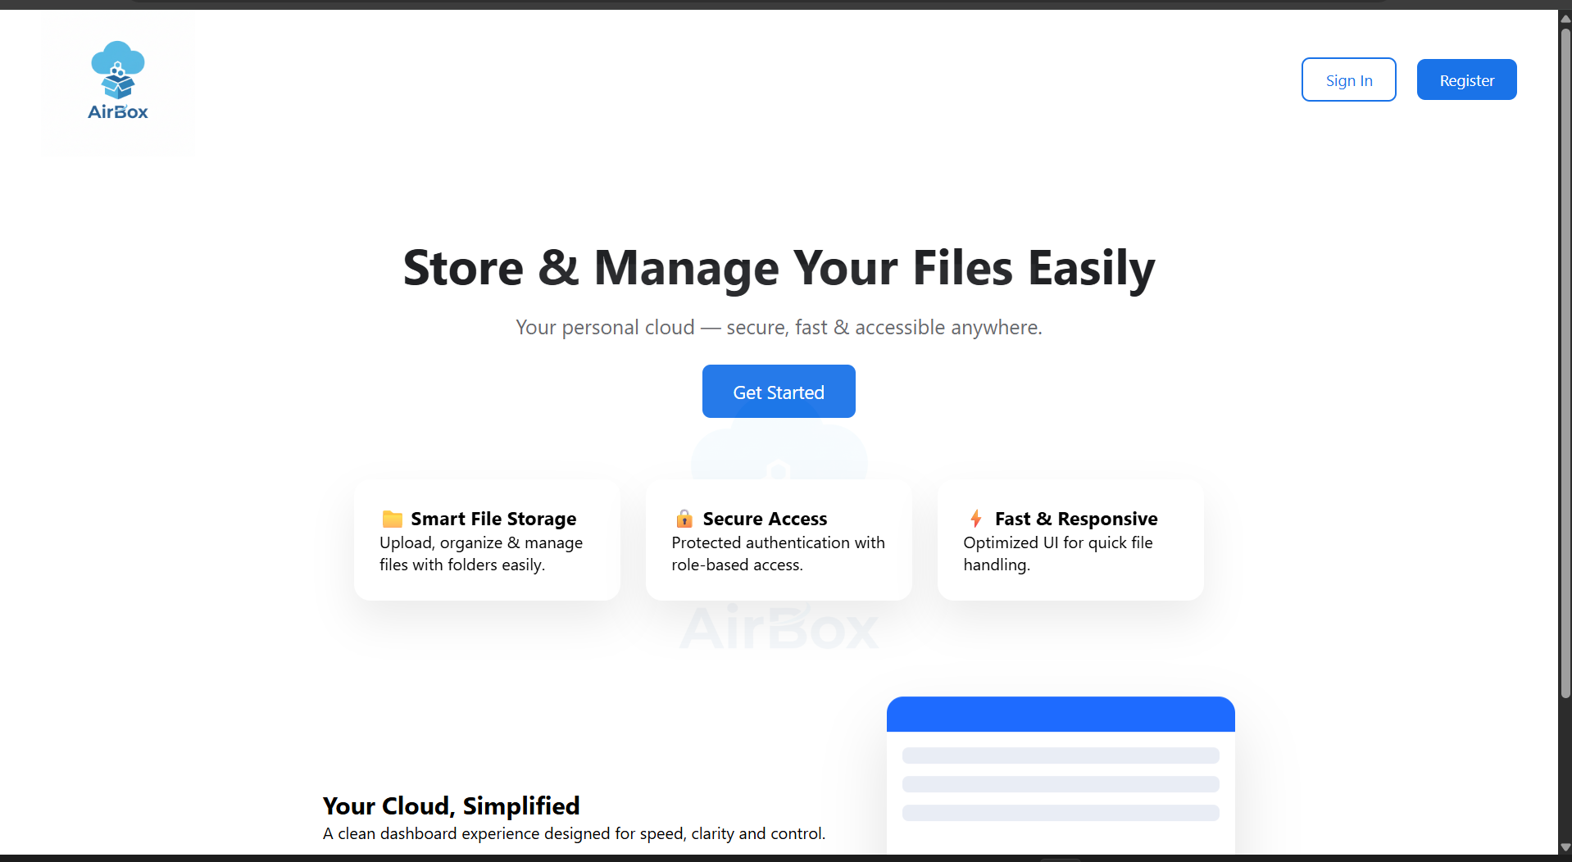

Registration page:
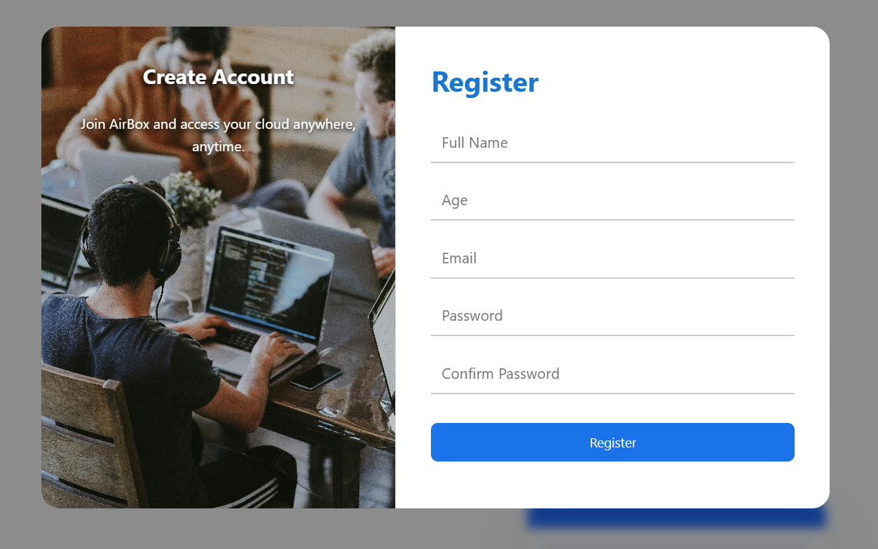

Sign-in page:
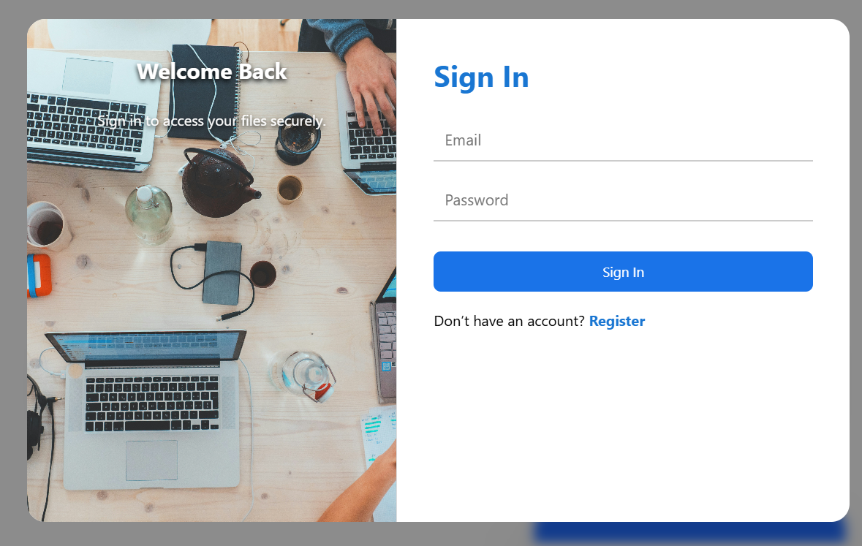

Dashboard:
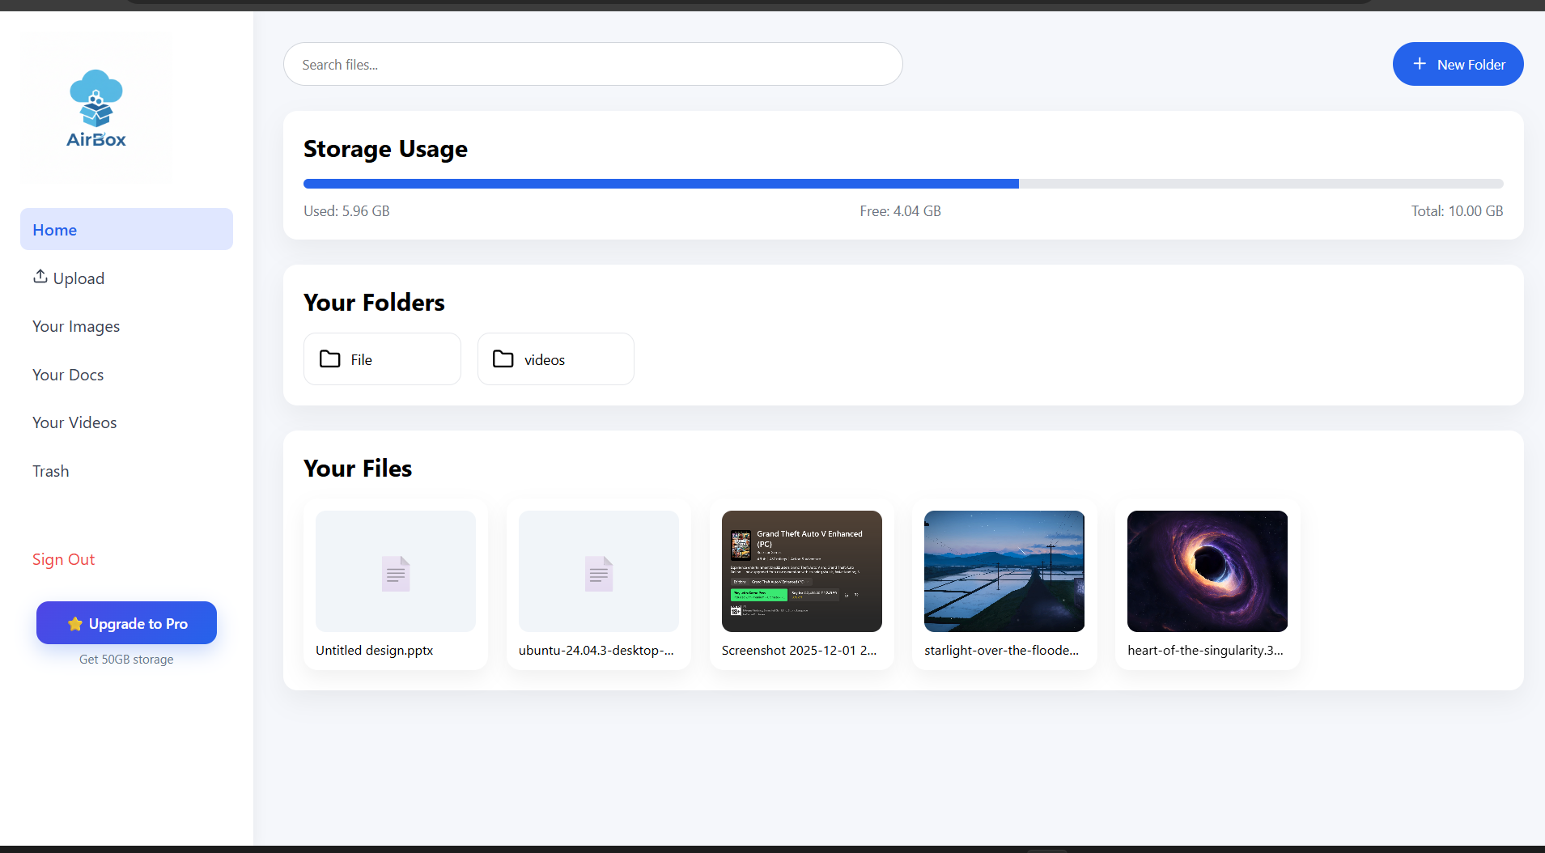

Admin Dashboard:
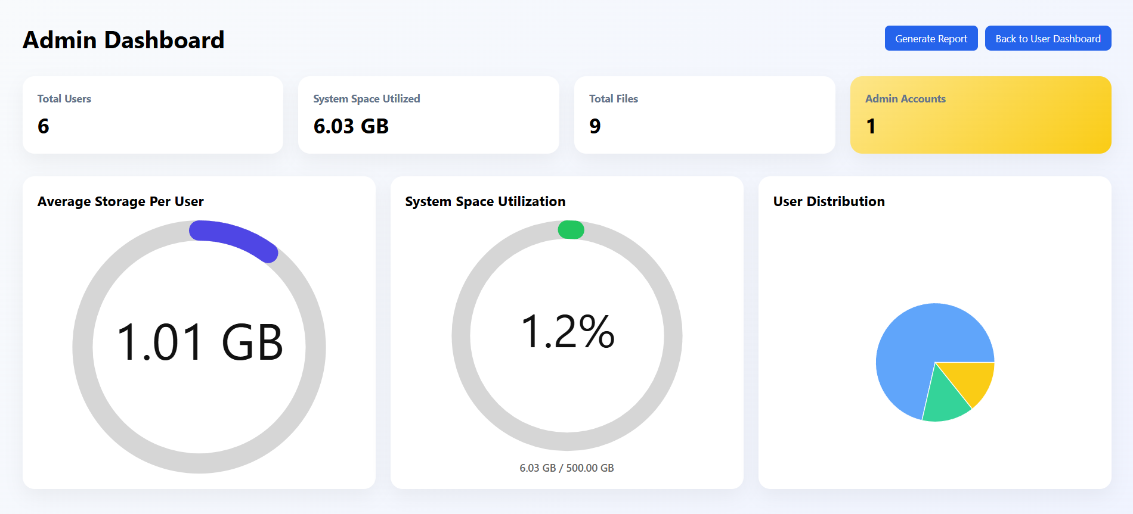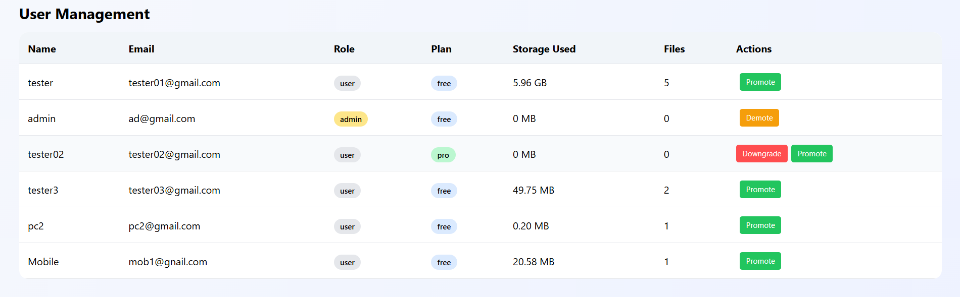

Report Generated:
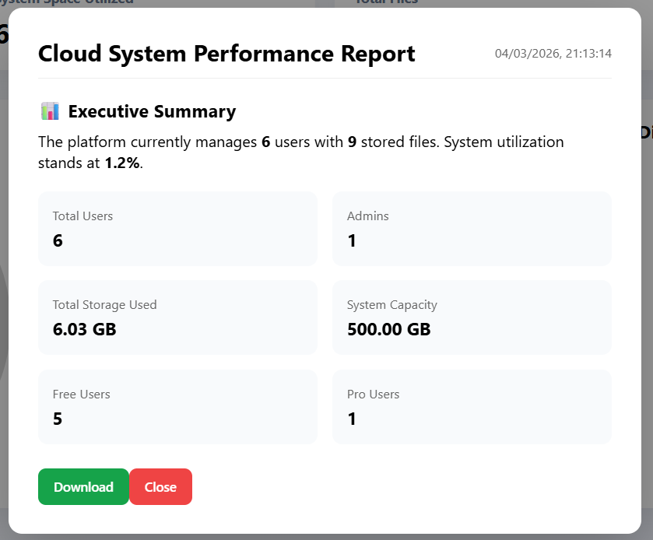

Limitations
- Limited Storage Plans:
Currently, the system provides only two storage plans (Free and Pro). This may not fully satisfy users who require flexible or customized storage options based on varying needs.
- Single Server Deployment:
The web-application is designed to operate on a single server machine within a local network. This limits scalability and may not be suitable for large-scale enterprise environments requiring distributed or cloud-based deployment.
- Network Dependency:
The system requires an active local network (Wi-Fi) connection to access and manage files. If the server machine is turned off or the network connection is unavailable, users cannot access the storage system.
- No Advanced File Sharing:
Features such as public file sharing, link-based sharing, cross-network access, or collaborative file editing are not currently implemented.
- Basic Security Implementation:
While user authentication and role-based access control are implemented, advanced security features such as end-to-end encryption, multi-factor authentication (MFA), and intrusion detection mechanisms are not included.
- Local Network Access Only:
The system is accessible only within the same network as the server machine. Remote access over the public internet is not currently implemented.

Scope for Future Work

Multiple Storage Plans:
Introduce additional subscription tiers with customizable storage limits, flexible pricing models, and enterprise-level plans to accommodate diverse user requirements.

Cloud Deployment & Scalability:
Deploy the system on cloud platforms to enable remote access over the internet. Integration with distributed storage systems, load balancing, and scalable server infrastructure can enhance performance and support large-scale usage.

File Sharing & Collaboration:
Implement advanced file-sharing features such as secure public/private links, permission-based access, and collaborative document management to allow multiple users to work on shared resources efficiently.

Advanced Security Features:
Enhance system security by implementing multi-factor authentication (MFA), data encryption mechanisms, secure file transfer protocols, and detailed activity logging to strengthen data protection.

Cross-Platform Accessibility:
Extend accessibility by optimizing the web web-application for broader device compatibility and potentially integrating progressive web web-application (PWA) features for improved user experience.

Analytics & Reporting:
Provide advanced dashboards with storage analytics, usage statistics, performance monitoring, and detailed reports to help administrators make data-driven decisions.

Conclusion
The Cloud Storage Web Web-application successfully provides a centralized and secure platform for storing and managing digital files within a network-based environment. By following a client–server architecture, where one system functions as the server and multiple client machines access the web-application through a web browser, the system ensures structured and efficient file management.
The integration of user authentication, role-based access control, storage limit management, real-time updates, and administrative controls enhances system reliability, security, and usability. Users can efficiently upload, download, and manage their files, while administrators can monitor user accounts and control storage allocation through a dedicated admin panel.
The web-application significantly reduces dependency on physical storage devices and minimizes manual file management processes. It improves data organization, accessibility within the network, and operational efficiency.
Overall, the system demonstrates a practical, scalable, and efficient web-based solution for modern digital storage requirements, with strong potential for further enhancements and real-world deployment.

References:
Cloud Storage Concept Reference:
Google Drive official website – https://drive.google.com
Dropbox official website – https://www.dropbox.com
Microsoft OneDrive official website – https://onedrive.live.com

Authentication & Security Reference:
OWASP (Open Web Web-application Security Project) – https://owasp.org
JWT (JSON Web Token) official documentation – https://jwt.io

Database Reference:
MongoDB official documentation – https://www.mongodb.com/docs

Backend Development Reference:
Node.js official documentation – https://nodejs.org
Express.js official documentation – https://expressjs.com

Frontend Development Reference:
React official documentation – https://react.dev
HTML, CSS, and JavaScript documentation – https://developer.mozilla.org
Desktop Web-application Development (if included):
Electron official documentation – https://www.electronjs.org

Diagram Tools Used:
Draw.io – https://www.drawio.com
PlantUML official website – https://plantuml.com

Development Tools Used:
Visual Studio Code, Node.js, MongoDB, HTML, CSS, JavaScript, React

